Spring Framework Starts
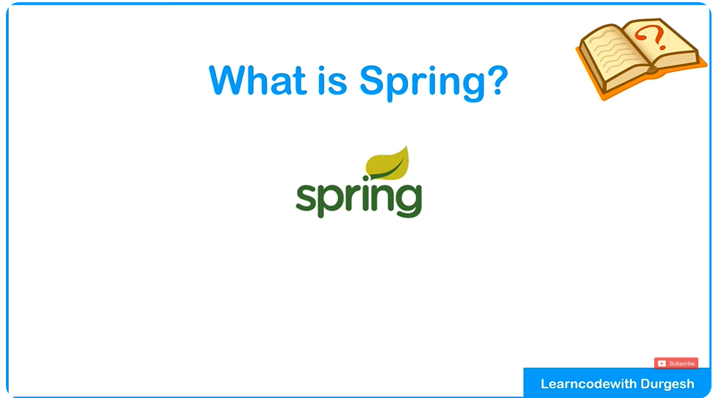

The Spring Framework is a powerful, lightweight, and comprehensive framework for building enterprise-level applications in Java. It provides a programming and configuration model to simplify the development of robust and scalable applications.

Key Features of Spring Framework:
- Dependency Injection (DI):
  - Simplifies object creation and management by enabling loose coupling between components.
- Aspect-Oriented Programming (AOP):
  - Allows separation of cross-cutting concerns (like logging, security) from the main business logic.
- Modularity:
  - Composed of several modules like Spring Core, Spring MVC, Spring Data, etc., so you can use only what you need.
- Integration:
  - Easily integrates with popular frameworks and tools like Hibernate, JPA, and third-party libraries.
- Declarative Programming:
  - Leverages annotations and XML-based configuration to reduce boilerplate code.
- Lightweight:
  - Works with plain Java objects (POJOs) and has minimal overhead compared to other enterprise frameworks.

Core Concepts:
- Inversion of Control (IoC):
  - Shifts control of object creation and lifecycle management from the application to the Spring container.
- Beans:
  - Objects managed by the Spring IoC container.
- Context:
  - Provides configuration and dependency resolution.

Applications of Spring Framework:
- Web Applications: Using Spring MVC or Spring WebFlux.
- Microservices: Spring Boot simplifies the creation of microservices.
- Data Access: Simplifies working with databases using Spring Data.
- Security: Spring Security provides robust authentication and authorization.
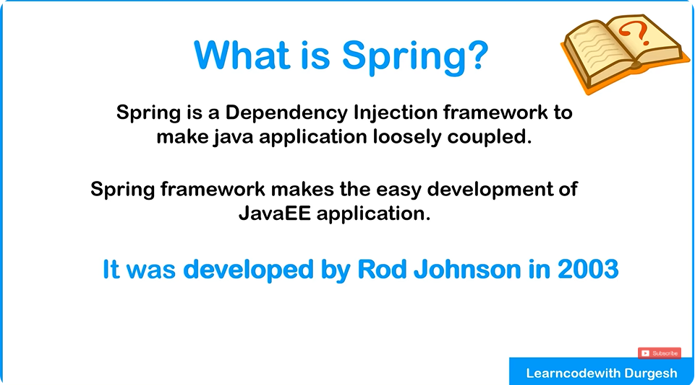
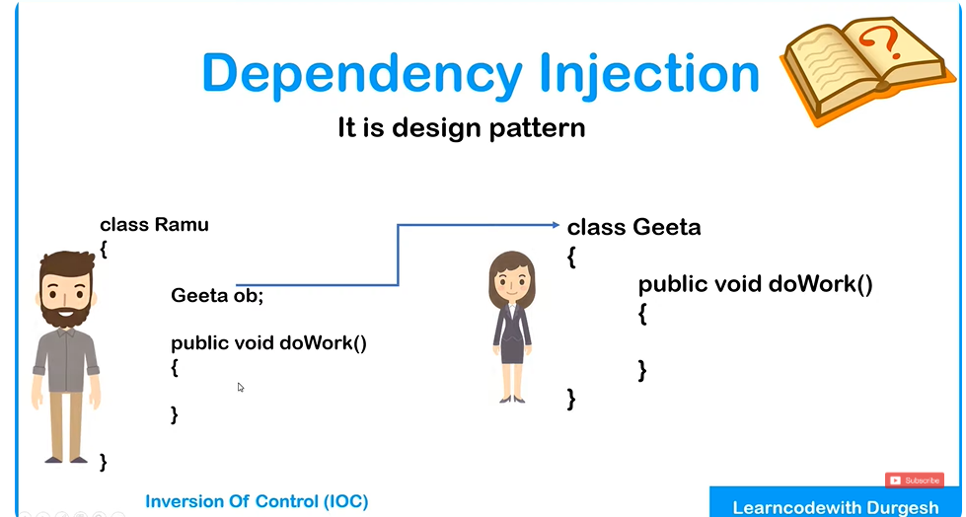
Normally we create object of suppose Geeta in this case using new keyword in Ramu Class
The problem is that it will be tightly coupled.
We will have to remove new and do changes in code for change in development

But with Dependency injection it can create and inject the object of one class into another by itself
Dependency Injection (DI):
Instead of a class creating the objects it needs (its "dependencies"), these objects are provided to the class from the outside. This makes the class flexible and easier to change or test.

Inversion of Control (IoC):
The control of creating and managing objects is handed over to a framework (like Spring). You just focus on using those objects; the framework takes care of creating and providing them.

Think of DI as someone handing you tools to do a job, and IoC as letting someone else organize the tools and workspace for you.
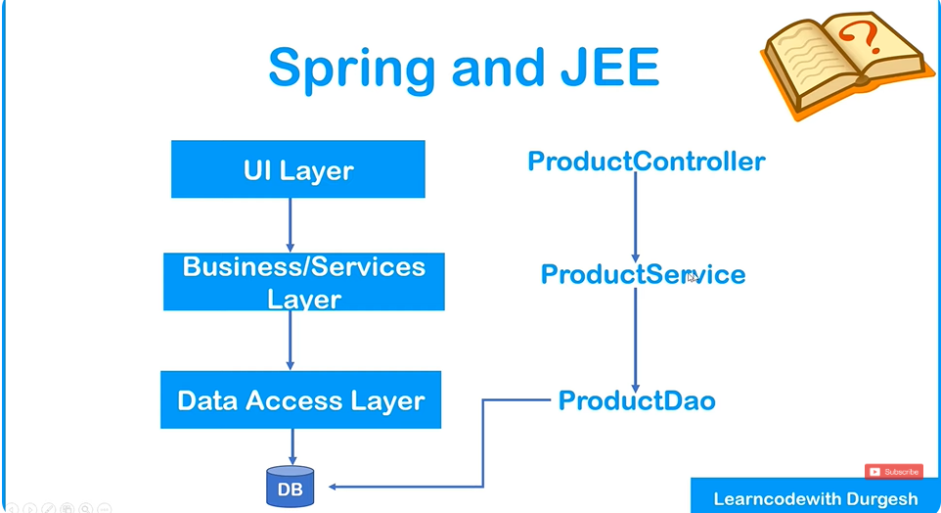
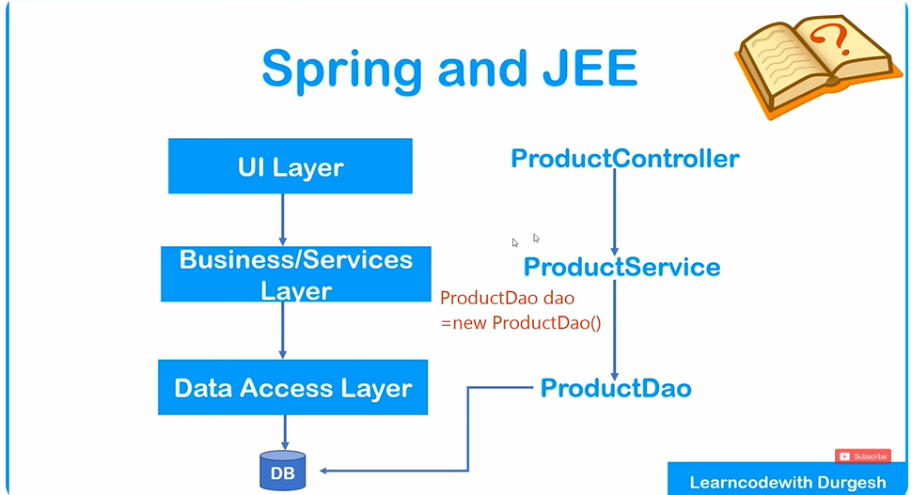
It’s a tightly coupled as previously explained in enterprise level application
Like if one day we change ProductDao.class we have to change ProductService.java
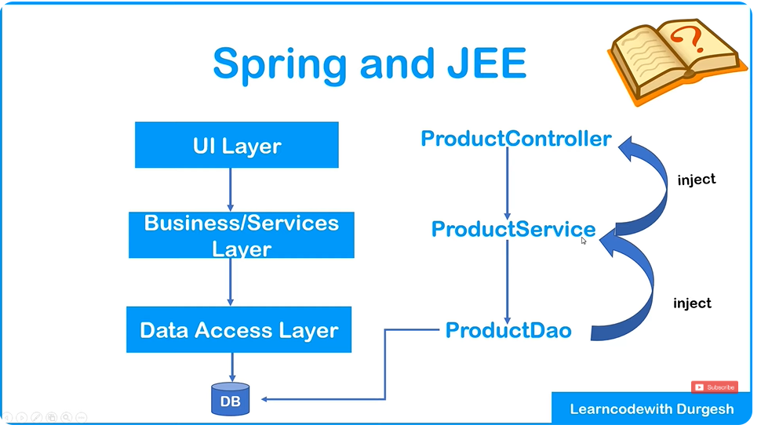
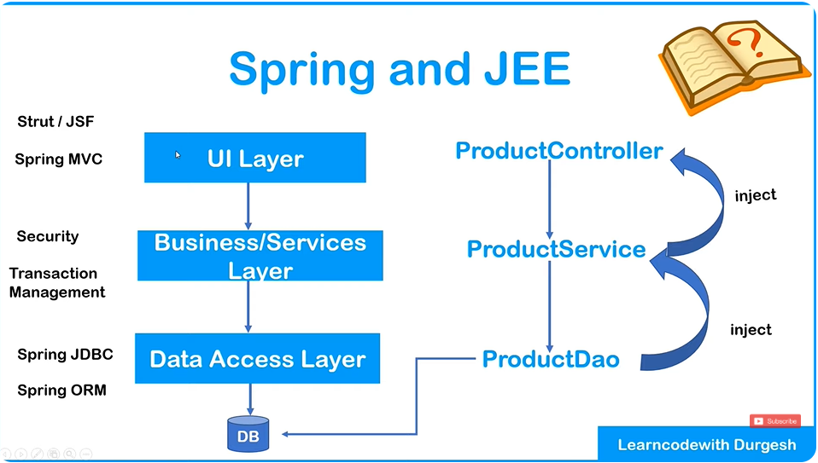

Overview of Spring Framework Modules | Spring Core | Spring Data Integration | Spring Web
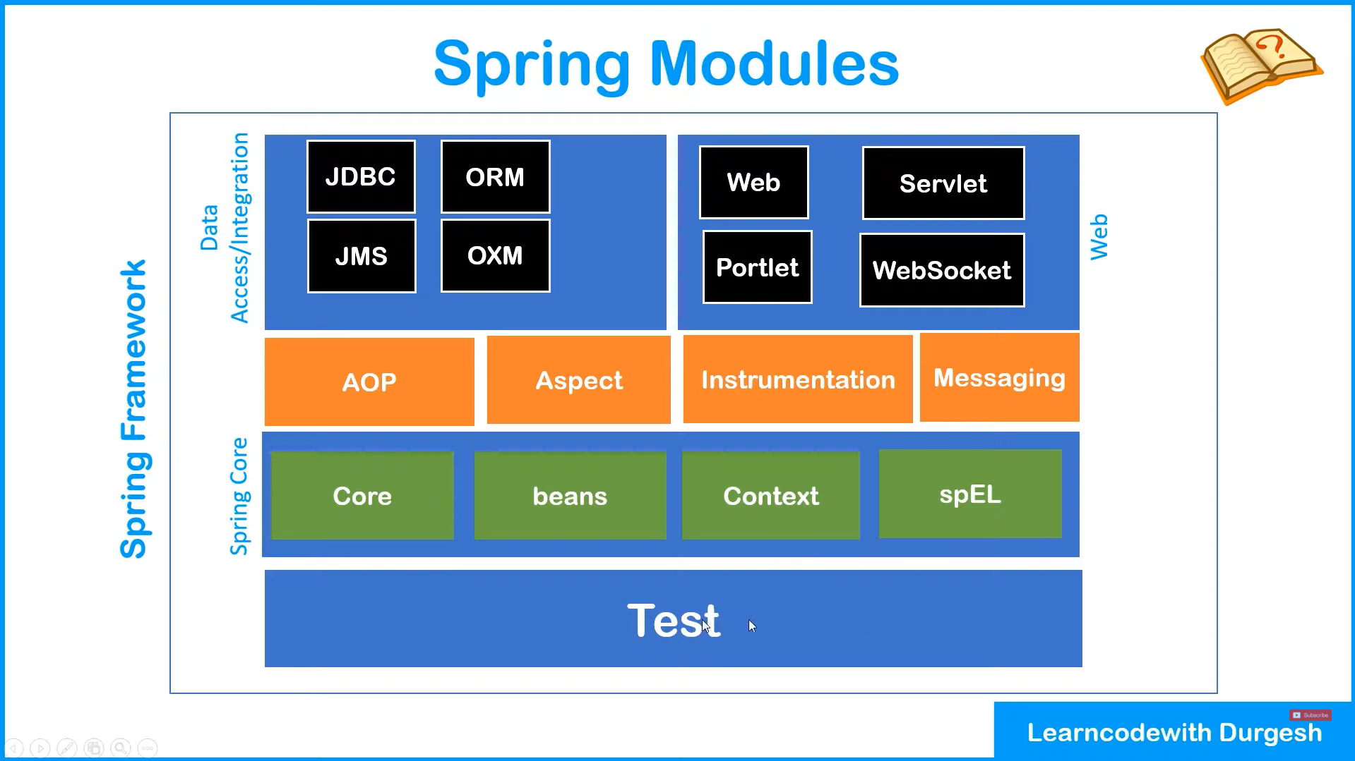
The image you uploaded outlines the key modules of the Spring Framework. Here's a detailed overview of each module, grouped by their areas of focus:

Spring Core (Green)
- Core:
  - Provides the essential functionality of the Spring framework, including the core features for dependency injection and configuration management. This is the foundation on which other Spring modules are built.
- Beans:
  - Deals with the configuration and management of beans (objects) within the Spring IoC (Inversion of Control) container. The Bean module handles the lifecycle, dependencies, and scopes of objects.
- Context:
  - Builds on the Bean module and provides a more advanced way to configure and manage beans, including integrating with other frameworks and providing better context for your application.
- SpEL (Spring Expression Language):
  - A powerful expression language that allows querying and manipulating objects at runtime. It can be used to access properties, perform calculations, and invoke methods in an easy-to-use syntax.

Spring Data Access / Integration (Blue)
- JDBC:
  - Provides a simpler, more flexible approach to interacting with relational databases using Java Database Connectivity (JDBC). It simplifies exception handling and transaction management.
- ORM (Object Relational Mapping):
  - Helps manage interactions between Java objects and relational databases. This module simplifies working with Hibernate, JPA (Java Persistence API), and other ORM frameworks.
- JMS (Java Message Service):
  - Supports sending and receiving messages between distributed applications, promoting messaging-based communication. It simplifies the integration of messaging systems like ActiveMQ.
- OXM (Object XML Mapping):
  - Provides tools to map Java objects to XML and vice versa. This is useful when working with web services or other systems that use XML as a data format.

Spring Web (Blue)
- Web:
  - General functionality for building web applications, including handling HTTP requests, responses, and session management.
- Servlet:
  - Provides functionality for creating web-based applications by extending traditional Java servlet capabilities, including building and managing HTTP-based services.
- WebSocket:
  - Allows for the creation of real-time, full-duplex communication channels over a single TCP connection. This is particularly useful for building modern, interactive web applications (like chat apps or live notifications).
- Portlet:
  - Enables the development of portlet-based applications (small applications or components in a larger web application). This module is primarily for creating web portals.

Spring Aspect-Oriented Programming (AOP) (Orange)
- AOP (Aspect-Oriented Programming):
  - A method of modularizing cross-cutting concerns (like logging, security, or transaction management) separately from the business logic. Spring AOP allows you to define aspects (modules) that can be applied to different parts of your application.
- Aspect:
  - Represents a modularization of a concern that cuts across multiple classes, 7such as logging or performance monitoring. It helps you keep code clean and modular by separating concerns.

Spring Instrumentation (Orange)
- Instrumentation:
  - Provides support for adding extra behavior to classes at runtime. This is useful for monitoring, performance profiling, or modifying bytecode dynamically during application execution.

Spring Messaging (Orange)
- Messaging:
  - Simplifies building messaging-based applications using different types of messaging protocols. This module integrates with JMS and provides an abstraction layer for working with various messaging systems.

Spring Testing (Blue)
- Test:
  - Provides comprehensive support for unit and integration testing. This module integrates with testing frameworks like JUnit and TestNG and allows you to test Spring components in isolation.

Spring IOC Container | What is Spring IOC Container | Spring Tutorial

Create the object in memory, Hold the object in memory, and inject the object into other(Dependency injection)
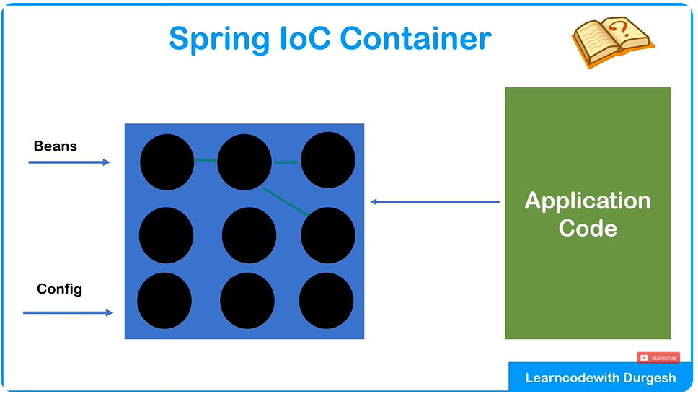
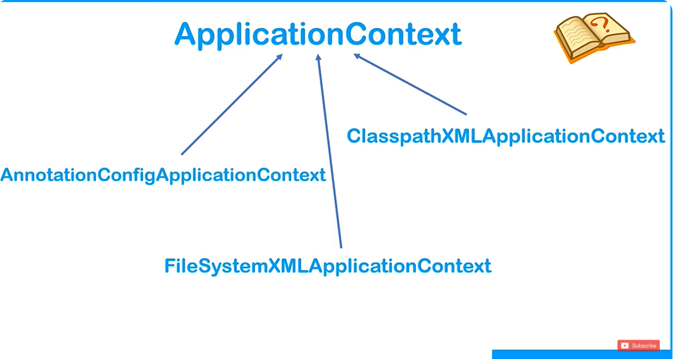
ApplicationContext is an interface

What is the Spring IoC Container?
The Spring IoC (Inversion of Control) Container is a core concept of the Spring Framework. It is responsible for managing the lifecycle and configuration of beans (objects) in a Spring-based application. The container handles the creation, wiring, and lifecycle management of beans, which are objects that form the backbone of an application. This is the foundation of Dependency Injection (DI) in Spring.

Key Concepts:
- Inversion of Control (IoC):
  - In a typical Java application, the developer controls how and when objects are created and managed. However, in IoC, this control is inverted: the Spring IoC Container manages the objects (beans), their dependencies, and their lifecycle.
  - IoC means that instead of creating objects manually, the Spring container creates and injects objects into your application as needed.
- Beans:
  - A bean is simply an object that is managed by the Spring IoC container. These objects are created based on the configuration provided to the container, which can be done either in XML, annotations, or Java-based configuration.
- Dependency Injection (DI):
  - DI is the process by which the Spring container injects dependencies (objects or services) into a bean at runtime. This means that instead of the bean creating or fetching its dependencies directly, the Spring container does that for you.
- Bean Lifecycle Management:
  - The Spring IoC container also manages the entire lifecycle of beans, such as their creation, initialization, and destruction.

Types of Spring IoC Containers:
- BeanFactory Container (Base Container):
  - BeanFactory is the simplest container in Spring, providing basic functionality like dependency injection and bean lifecycle management.
  - It is typically used in simple or resource-constrained applications.
  - XmlBeanFactory was historically used, but it is now deprecated and replaced by ApplicationContext.
- ApplicationContext Container (Advanced Container):
  - ApplicationContext is a more advanced container that extends BeanFactory and includes additional features like event propagation, declarative mechanisms for creating beans, and more.
  - It is the most commonly used container in Spring applications.
  - There are different types of ApplicationContext, such as:
    - ClassPathXmlApplicationContext: Loads beans from an XML configuration file.
    - AnnotationConfigApplicationContext: Used for Java-based configuration using annotations.
    - GenericWebApplicationContext: For web-based Spring applications.

How the Spring IoC Container Works:
- Configuration:
  - The IoC container is configured through XML files, annotations, or Java classes.
  - XML Configuration: Traditionally, beans were defined in XML files (using <bean> tags).
  - Annotation-Based Configuration: Modern Spring uses annotations like @Component, @Autowired, @Configuration, etc.
  - Java Configuration: Beans can be configured using Java code, often through @Configuration annotated classes and methods.
- Creation of Beans:
  - The container creates beans at runtime based on the configuration provided.
  - It injects dependencies into the beans automatically (if DI is defined), either through constructor injection or setter injection.
- Dependency Injection (DI):
  - The IoC container manages the creation and injection of dependencies into beans. It can inject objects into beans automatically based on the configuration.
  - DI can be:
    - Constructor Injection: Dependencies are provided through the constructor of the class.
    - Setter Injection: Dependencies are set via setter methods.
- Lifecycle Management:
  - The Spring IoC container manages the lifecycle of beans, including initialization, destruction, and other lifecycle callbacks like @PostConstruct and @PreDestroy.

Benefits of Using Spring IoC Container:
- Loose Coupling:
  - By using IoC, Spring promotes loose coupling between components. This means that classes don’t need to be directly responsible for creating or managing their dependencies.
  - Components can be reused, easily tested, and swapped out.
- Flexibility and Maintainability:
  - Spring IoC allows developers to configure objects without hard-coding them. Beans can be defined externally and modified without changing the application’s code.
  - Configuration can be changed through XML, annotations, or Java configuration.
- Testability:
  - With DI, it is easy to inject mock or stub beans for unit testing, making your application more testable.
- Centralized Configuration:
  - All configuration related to the creation of beans, and their dependencies, is centralized in the IoC container, leading to easier management of the application.

Ways of Injecting dependencies | Types of dependencies handled by IOC Container

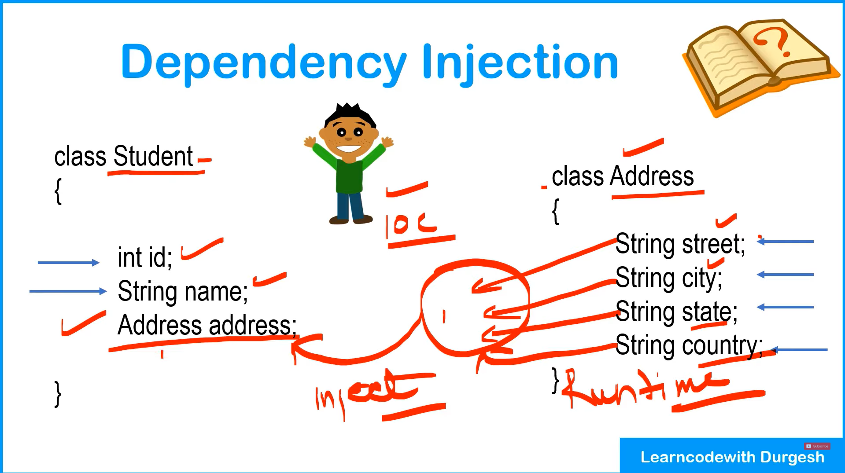
Types of dependencies Injection
Setter Injection is also called property Injection

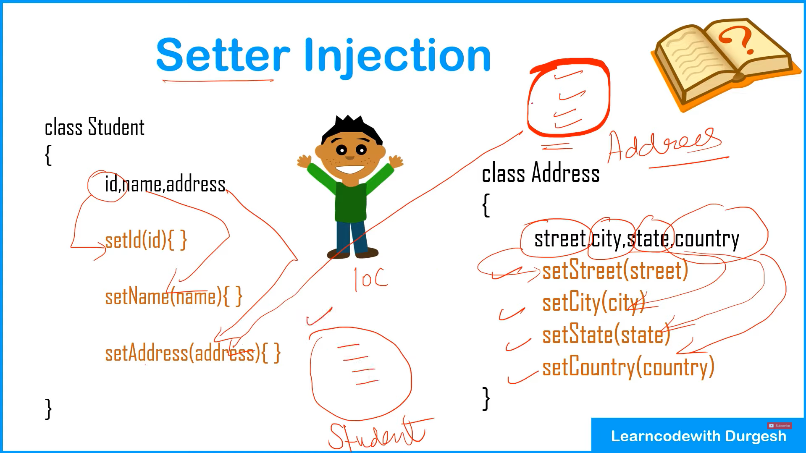

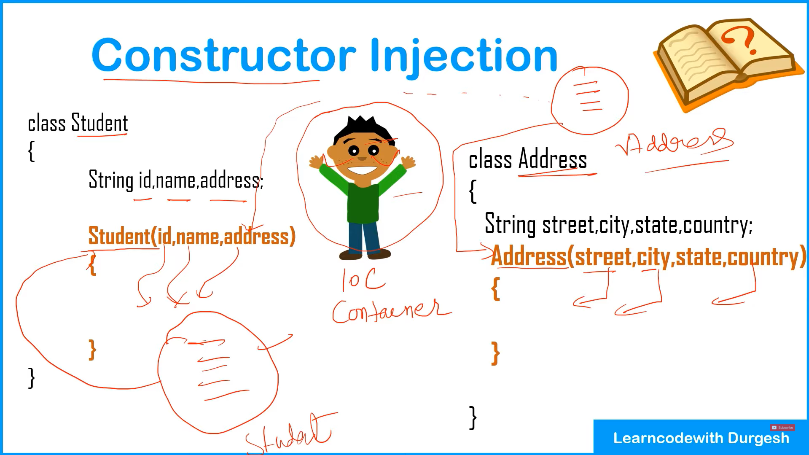
CONFIGURATION FILE
The class we provide to IOC or XML WE say is called as Beans
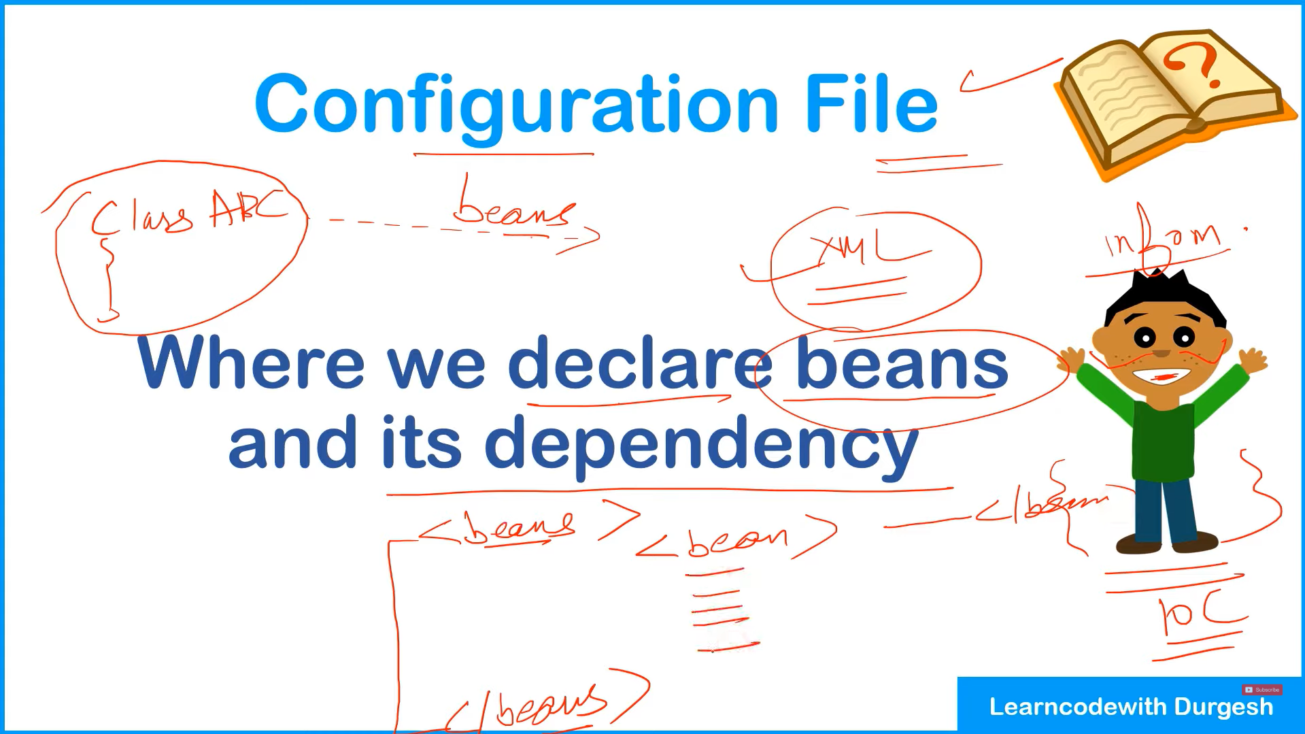
Datatypes In Dependency
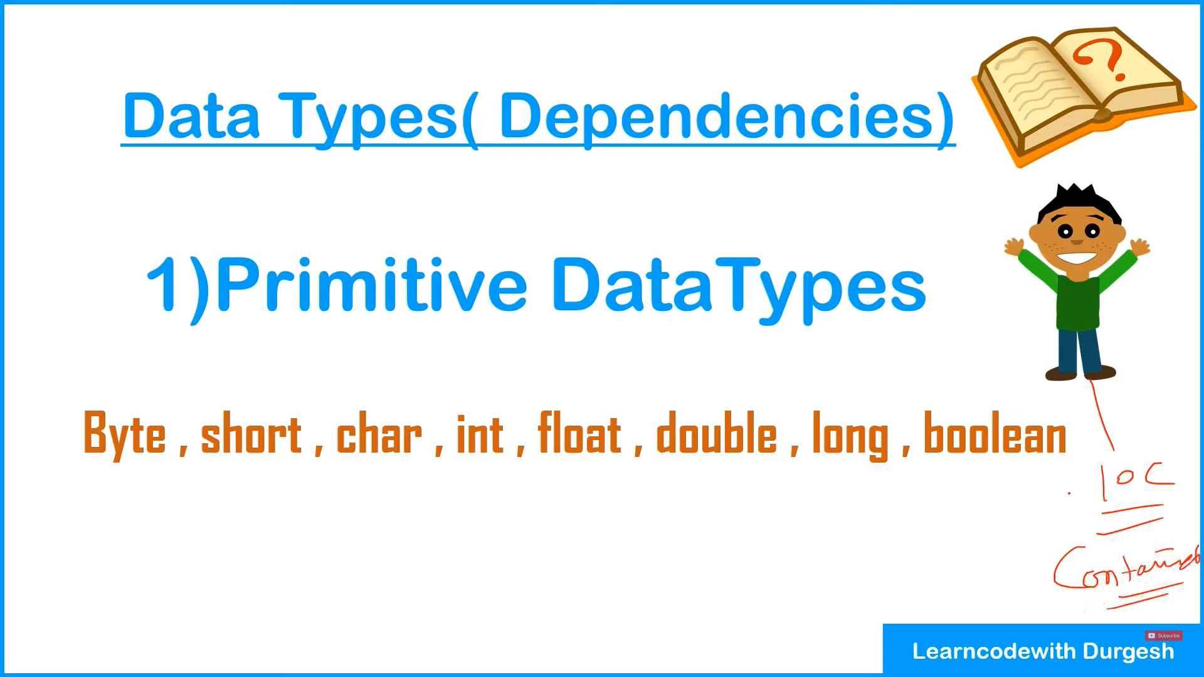
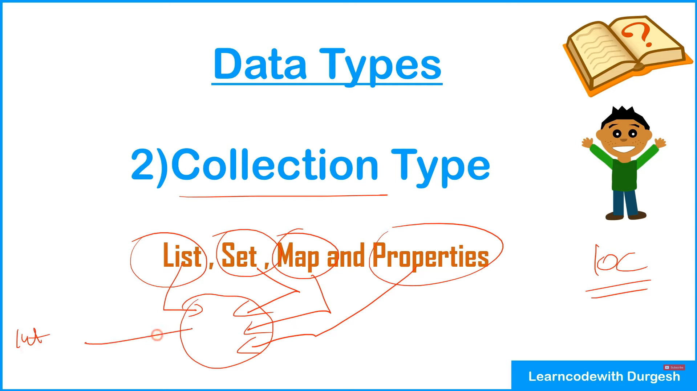
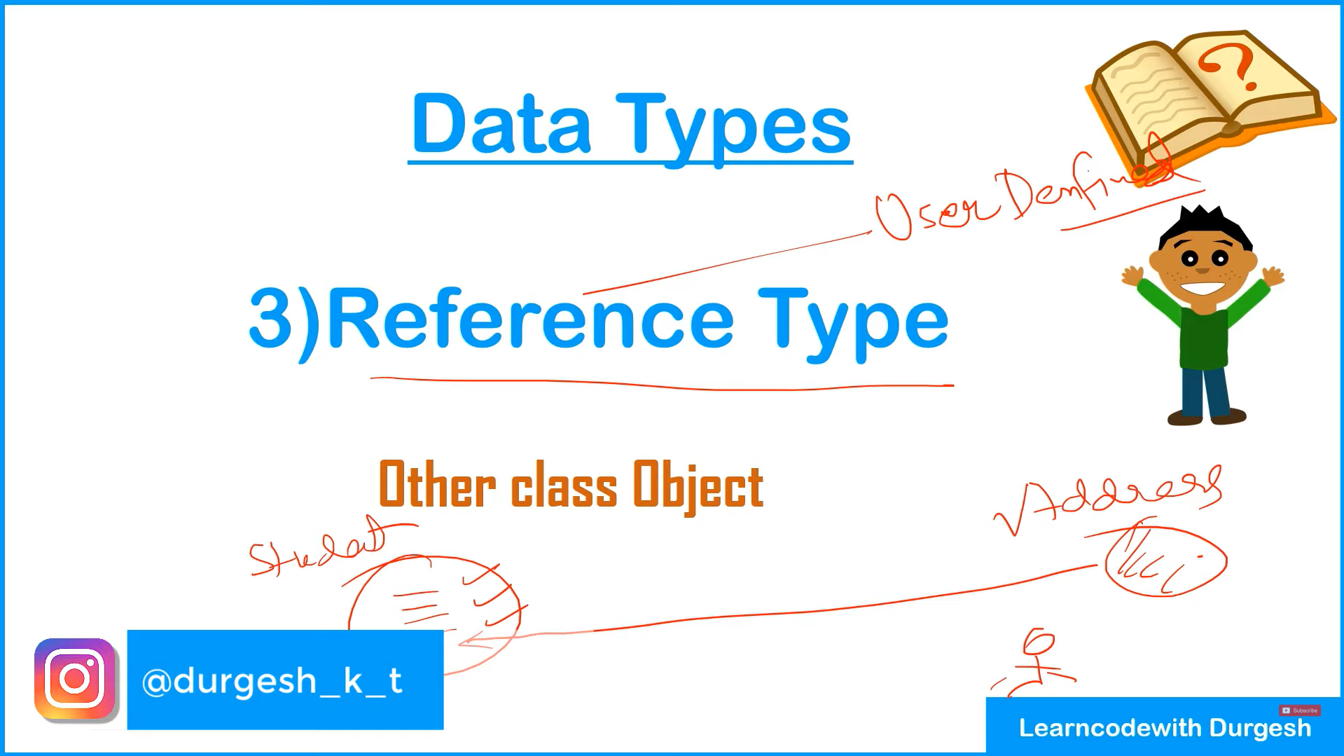

Ways of Injecting Dependencies in Spring IoC Container
In Spring, Dependency Injection (DI) is the mechanism by which the Spring IoC container injects dependencies (i.e., the required objects) into a class, rather than the class creating those dependencies itself. The Spring IoC container manages the entire lifecycle of beans and injects dependencies automatically.
There are three main ways of injecting dependencies into a Spring bean:

1. Constructor Injection
Constructor injection is the most commonly used method in Spring. In this method, dependencies are provided to the bean through its constructor.
- How it works:
  - Spring identifies the constructor of the bean that accepts parameters and provides the required dependencies to the constructor.
  - This method ensures that the bean is created with all its required dependencies at the time of creation, making the class immutable (if all dependencies are required at the time of initialization).

Example:
java
Copy code
@Component
public class Car {
private Engine engine;

@Autowired // Tells Spring to inject Engine dependency
public Car(Engine engine) {
this.engine = engine;
}

public void start() {
engine.start();
}
}

@Component
public class Engine {
public void start() {
System.out.println("Engine started");
}
}
In this example:
- The Car class has a constructor that accepts an Engine object.
- Spring injects the Engine dependency when it creates the Car bean.

2. Setter Injection
In setter injection, Spring injects dependencies using setter methods (i.e., through JavaBean-style setters).
- How it works:
  - Spring calls the setter methods of the bean after the bean is instantiated, providing the required dependencies.
  - This method allows optional dependencies to be injected. If a bean doesn’t have required dependencies, the setter method can be left empty, and Spring will not inject a value.

Example:
java
Copy code
@Component
public class Car {
private Engine engine;

@Autowired
public void setEngine(Engine engine) {
this.engine = engine;
}

public void start() {
engine.start();
}
}

@Component
public class Engine {
public void start() {
System.out.println("Engine started");
}
}
In this example:
- The Car class has a setter method setEngine(), and Spring injects the Engine dependency through this setter.

3. Field Injection
Field injection is the simplest form of DI where Spring directly injects dependencies into the fields of the class. It is done using the @Autowired annotation on the fields, and Spring automatically injects the required dependencies.
- How it works:
  - Spring will inject the dependency into the private fields directly without the need for constructors or setters.
  - Field injection is less preferred compared to constructor injection because it makes testing harder and can lead to issues if the bean is not properly initialized.

Example:
java
Copy code
@Component
public class Car {
@Autowired
private Engine engine; // Spring injects the Engine dependency directly

public void start() {
engine.start();
}
}

@Component
public class Engine {
public void start() {
System.out.println("Engine started");
}
}
In this example:
- The Car class has the Engine dependency directly injected into the field by Spring.

4. Autowiring by Qualifier (When Multiple Beans of Same Type Exist)
If you have multiple beans of the same type, Spring needs to know which bean to inject. This is handled using the @Qualifier annotation along with @Autowired.
- How it works:
  - The @Qualifier annotation helps specify which bean to inject when there are multiple candidates.

Example:
java
Copy code
@Component
public class Car {
private Engine engine;

@Autowired
@Qualifier("dieselEngine") // Specify which engine to inject
public Car(Engine engine) {
this.engine = engine;
}

public void start() {
engine.start();
}
}

@Component("dieselEngine")
public class DieselEngine implements Engine {
public void start() {
System.out.println("Diesel engine started");
}
}

@Component("electricEngine")
public class ElectricEngine implements Engine {
public void start() {
System.out.println("Electric engine started");
}
}
In this example:
- There are two Engine beans: DieselEngine and ElectricEngine.
- The @Qualifier("dieselEngine") specifies which bean should be injected into the Car bean.

Types of Dependencies Handled by Spring IoC Container
The Spring IoC Container handles a variety of dependencies, making it an extremely flexible and powerful framework for managing objects in your application. Below are the main types of dependencies that Spring manages:
- Constructor Dependencies (Mandatory Dependencies):
  - These are dependencies that must be provided at the time of bean creation. If they are not provided, Spring will throw an exception.
  - Typically injected using constructor injection.
- Setter Dependencies (Optional Dependencies):
  - These are dependencies that can be injected after the bean is created, typically using setter injection.
  - They are not mandatory; the bean can exist without them.
- Dependencies Between Beans:
  - The Spring container is capable of resolving dependencies between different beans in the context. When one bean depends on another, Spring automatically handles the wiring of these beans.
  - Dependencies can be circular as well, and Spring will resolve them properly.
- Primitive Type Dependencies:
  - Spring can inject primitive data types such as int, String, double, etc.
  - These dependencies can be injected via constructor injection, setter injection, or field injection.
- Collections (List, Set, Map, etc.):
  - Spring can inject collections into a bean. If a bean needs a list of other beans, Spring can automatically wire them using annotations or XML configuration.
- Bean Factory Dependencies:
  - Spring supports bean factories, where a bean is created on demand. Spring will manage these dependencies and inject them as needed.
- Custom Bean Dependencies:
  - Spring can inject custom beans that are not part of standard Java libraries. You can define your own beans and have them injected where needed.
- Qualifier Dependencies:
  - When there are multiple beans of the same type, Spring can handle the ambiguity by using the @Qualifier annotation to specify which bean should be injected.

Summary of Dependency Injection Methods:
- Constructor Injection: Injects dependencies via the constructor, ensuring that dependencies are provided when the object is created.
- Setter Injection: Dependencies are provided via setter methods, offering more flexibility and allowing optional dependencies.
- Field Injection: Dependencies are directly injected into fields without needing setters or constructors (less preferred for testing).
- Qualifier Injection: Used to differentiate between multiple beans of the same type when autowiring.

Lets Dive Into it practically and Screeshots notes will be added

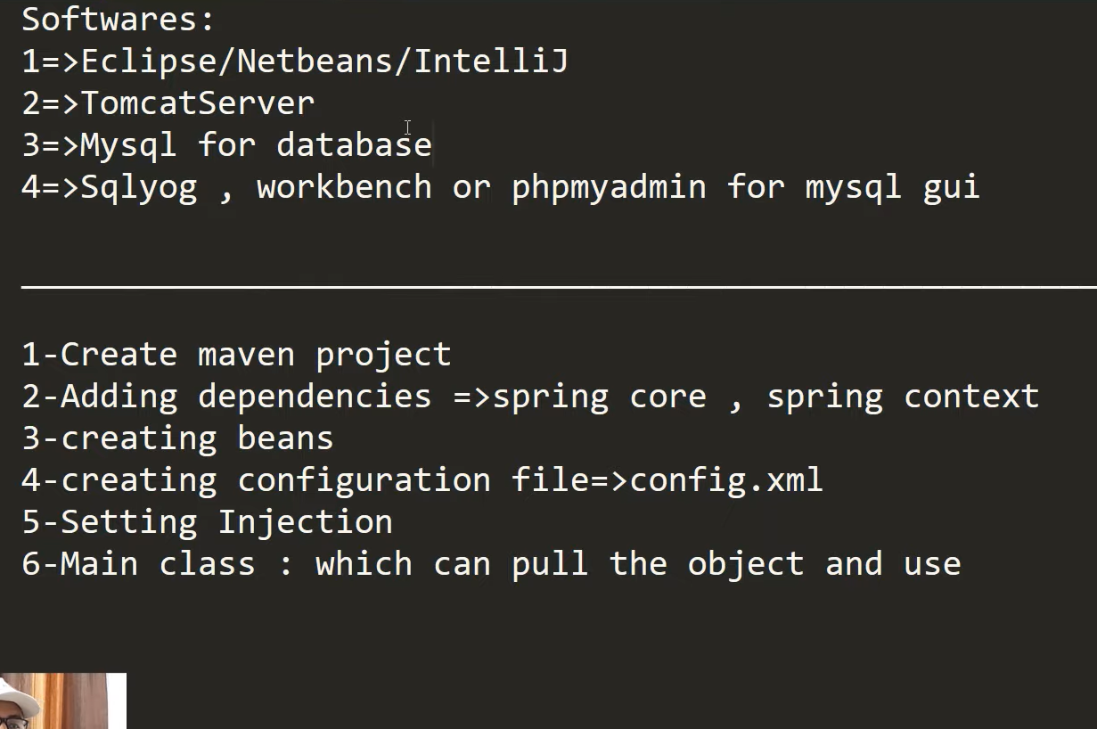
Maven project with archetype quickstart
We use maven so we can directly add dependency in pom.xml instead of manually getting extracting and pasting jars
Explaining beans and java pojo

What is a Bean?
In Spring, a Bean is simply an object that is managed by the Spring IoC (Inversion of Control) container. Beans are the backbone of any Spring-based application. They are defined in the Spring configuration file (or through annotations) and are instantiated, assembled, and managed by the Spring container.

Key Characteristics of a Spring Bean:
- Managed by Spring Container: The lifecycle (creation, initialization, and destruction) of beans is handled by the Spring IoC container.
- Defined in Configuration: Beans can be declared in XML configuration files, Java-based configuration, or through annotations like @Component or @Bean.
- Reusable and Singleton by Default: By default, Spring beans are singleton objects, meaning the same instance is reused across the application (can be changed to prototype if needed).

What is a POJO?
POJO stands for Plain Old Java Object. It is a simple Java class that:
- Doesn’t follow any special Java object model, like EJB (Enterprise Java Beans).
- Contains no special annotations, interfaces, or inheritance requirements.
- Typically consists of:
  - Private fields (attributes).
  - Public getters and setters to access or modify the fields.
  - Optionally, methods like toString(), hashCode(), equals().

How Are Beans and POJOs Related?
A Spring Bean is often a POJO. Essentially, a POJO becomes a Spring Bean when it is registered in the Spring IoC container.
- All Beans are POJOs.
- However, not all POJOs are Beans unless they are explicitly managed by Spring.

Student.java
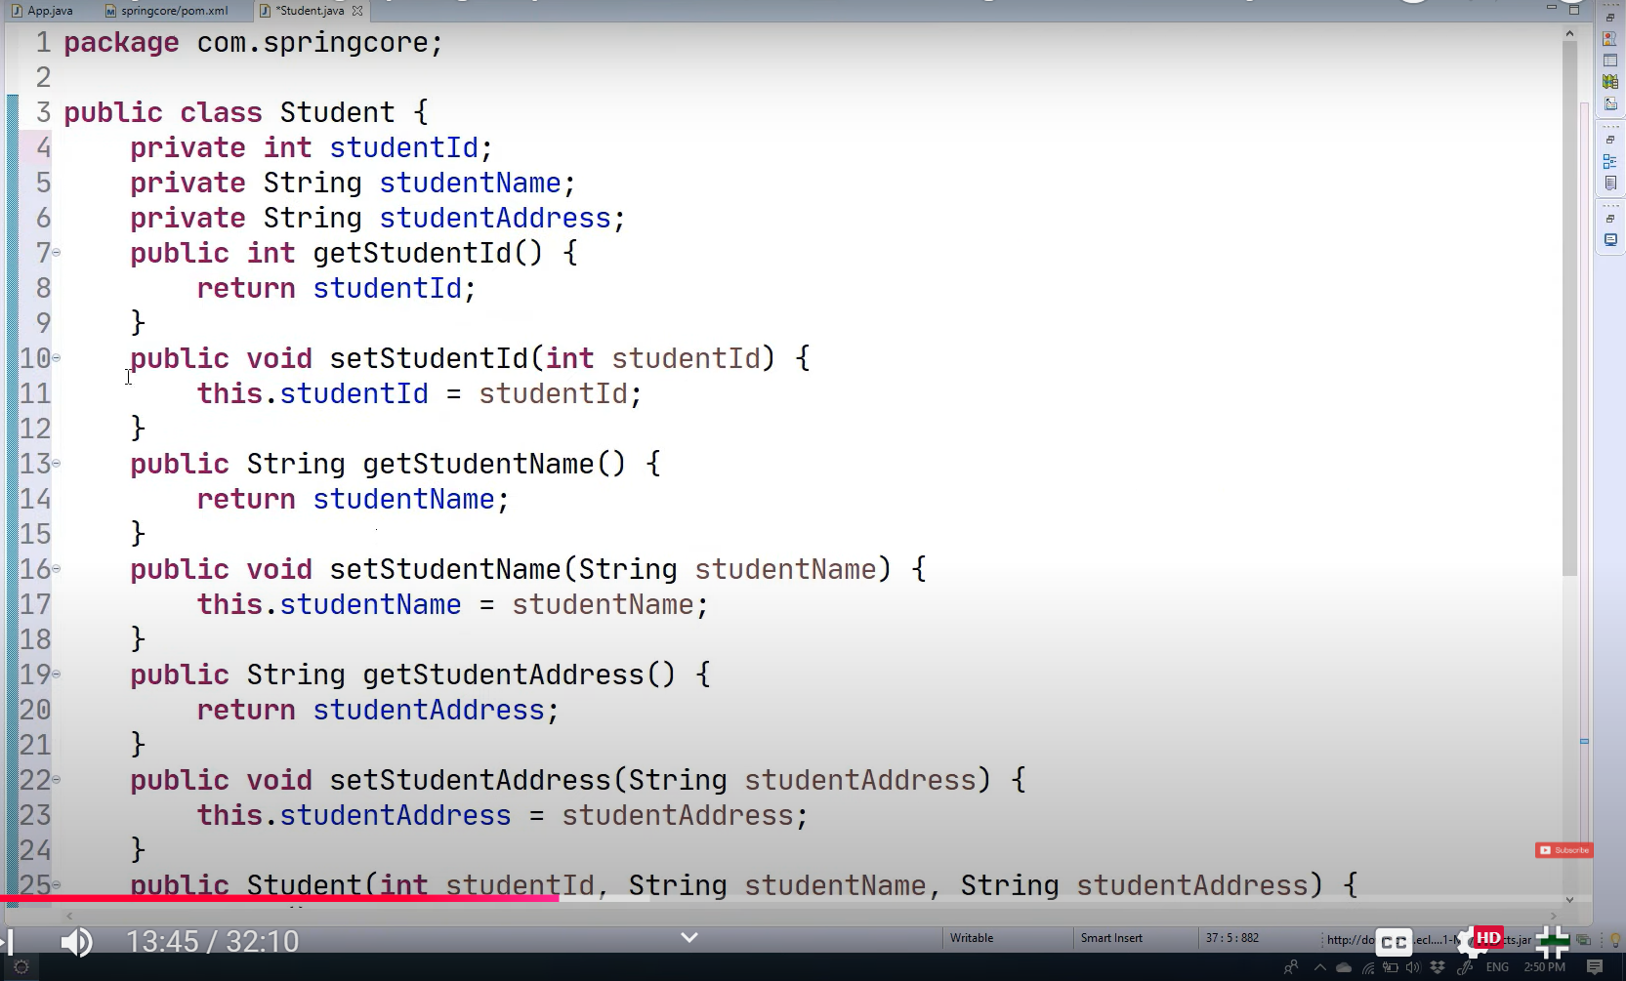
Genereate getter setters and constructors as we did in hibernate
Generate to string method also
Now we will create configuration file
Basic From Documentation
<?xml version="1.0" encoding="UTF-8"?>
<beans xmlns="http://www.springframework.org/schema/beans"
xmlns:xsi="http://www.w3.org/2001/XMLSchema-instance"
xmlns:context="http://www.springframework.org/schema/context"
xmlns:p="http://www.springframework.org/schema/p"
xsi:schemaLocation="http://www.springframework.org/schema/beans
http://www.springframework.org/schema/beans/spring-beans.xsd
http://www.springframework.org/schema/context
http://www.springframework.org/schema/context/spring-context.xsd">

</beans>

Complete
<?xml version="1.0" encoding="UTF-8"?>

<beans xmlns="http://www.springframework.org/schema/beans"
xmlns:xsi="http://www.w3.org/2001/XMLSchema-instance"
xmlns:context="http://www.springframework.org/schema/context"
xmlns:p="http://www.springframework.org/schema/p"
xsi:schemaLocation="http://www.springframework.org/schema/beans
http://www.springframework.org/schema/beans/spring-beans.xsd
http://www.springframework.org/schema/context
http://www.springframework.org/schema/context/spring-context.xsd">
<!-- This is our bean for StudentClass-->
<bean class="com.springcore.Student" name="student1">
<property name="StudentId">
<value>165</value></property>

<property name="StudentName">
<value>Light</value></property>

<property name="StudentAddress">
<value>Thane</value></property>

</bean>

</beans>

Using property tags we do setter injection by explaining metadata

Now to complete Dependency Injection using IOC will go in main class and create object using that xml and ioc
If we have multiple xmls we can also pass array like this
package com.springcore;

import org.springframework.context.ApplicationContext;
import org.springframework.context.support.ClassPathXmlApplicationContext;

/**
* Hello world!
*
*/
public class App
{
public static void main( String[] args )
{
System.out.println( "Hello World!" );
ApplicationContext context=new ClassPathXmlApplicationContext("config.xml");
//Typecasting the received object we learned this in Hibernate TOO
Student s1=(Student)context.getBean("student1");
System.out.println(s1);
}
}

Property injection using p Schema and using value as attribute
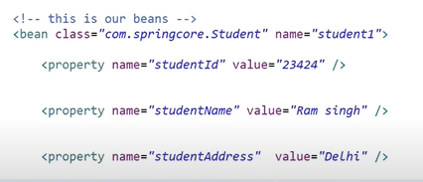
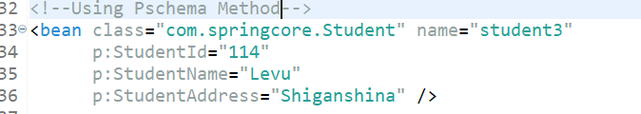
<!--Using Pschema Method-->
<bean class="com.springcore.Student" name="student3"
p:StudentId="114"
p:StudentName="Levu"
p:StudentAddress="Shiganshina" />

Complete Codes for Setter Injection basics

Config.xml
<?xml version="1.0" encoding="UTF-8"?>

<beans xmlns="http://www.springframework.org/schema/beans"
xmlns:xsi="http://www.w3.org/2001/XMLSchema-instance"
xmlns:context="http://www.springframework.org/schema/context"
xmlns:p="http://www.springframework.org/schema/p"
xsi:schemaLocation="http://www.springframework.org/schema/beans
http://www.springframework.org/schema/beans/spring-beans.xsd
http://www.springframework.org/schema/context
http://www.springframework.org/schema/context/spring-context.xsd">
<!-- This is our 1st bean for StudentClass-->
<!--Using Value as Element-->
<bean class="com.springcore.Student" name="student1">
<property name="StudentId">
<value>165</value></property>

<property name="StudentName">
<value>Light</value></property>

<property name="StudentAddress">
<value>Thane</value></property>
<!-- This is our 2nd bean for StudentClass
-->
</bean>
<!--Using Value as Attribute-->
<bean class="com.springcore.Student" name="student2">
<property name="StudentId" value="124"></property>
<property name="StudentName" value="Lelouch"></property>

<property name="StudentAddress" value="Britain"></property>

</bean>
<!--This is our 3rd Bean for Student Class-->
<!--Using Pschema Method-->
<bean class="com.springcore.Student" name="student3"
p:StudentId="114"
p:StudentName="Levu"
p:StudentAddress="Shiganshina" />

</beans>

App.java
package com.springcore;

import org.springframework.context.ApplicationContext;
import org.springframework.context.support.ClassPathXmlApplicationContext;

/**
* Hello world!
*
*/
public class App
{
public static void main( String[] args )
{
System.out.println( "Hello World!" );
ApplicationContext context=new ClassPathXmlApplicationContext("config.xml");
//Typecasting the received object we learned this in Hibernate TOO
Student s1=(Student)context.getBean("student1");
Student s2=(Student)context.getBean("student2");
Student s3=(Student)context.getBean("student3");
System.out.println(s1);
System.out.println(s2);
System.out.println(s3);
}
}

Student.java
package com.springcore;

public class Student {
private int StudentId;
private String StudentName;
private String StudentAddress;
public int getStudentId() {
return StudentId;
}
public void setStudentId(int studentId) {
System.out.println("We are using Setter Injection...");
StudentId = studentId;
}
public String getStudentName() {
return StudentName;
}
public void setStudentName(String studentName) {
StudentName = studentName;
}
public String getStudentAddress() {
return StudentAddress;
}
public void setStudentAddress(String studentAddress) {
StudentAddress = studentAddress;
}
public Student(int studentId, String studentName, String studentAddress) {
super();
StudentId = studentId;
StudentName = studentName;
StudentAddress = studentAddress;
}
public Student() {
super();
// TODO Auto-generated constructor stub
}
@Override
public String toString() {
return "Student [StudentId=" + StudentId + ", StudentName=" + StudentName + ", StudentAddress=" + StudentAddress
+ "]";
}

}

How to inject collection types List , Set , Map and Properties | Spring Tutorial

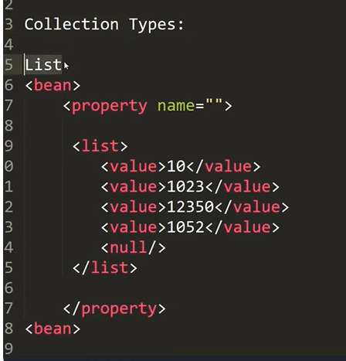
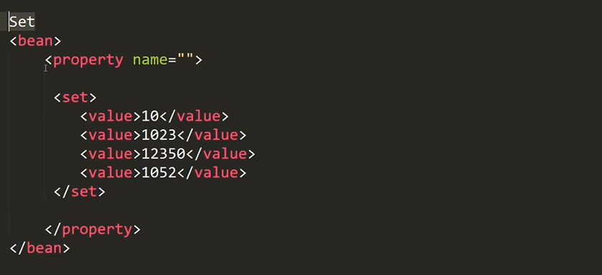
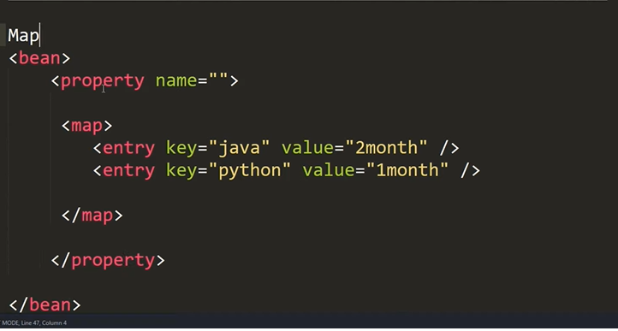
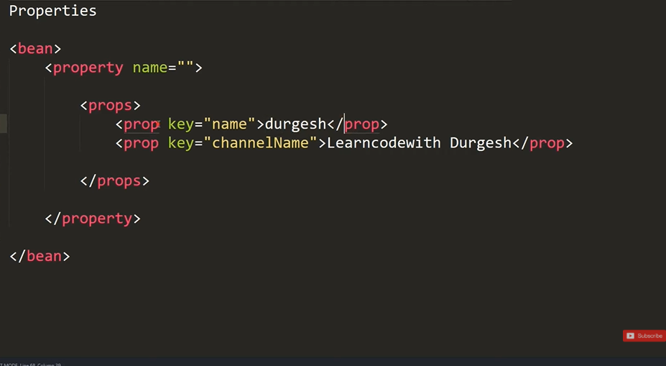
Practical Example of this
Test.java
package com.springcore.collections;

import org.springframework.context.ApplicationContext;
import org.springframework.context.support.ClassPathXmlApplicationContext;

import com.springcore.Student;

public class Test {

public static void main( String[] args )
{
System.out.println( "Hello World!" );
ApplicationContext context=new ClassPathXmlApplicationContext("com/springcore/collections/conf.xml");
//Typecasting the received object we learned this in Hibernate TOO
Employee emp1=(Employee)context.getBean("E1");
Employee emp2=(Employee)context.getBean("E2");
Employee emp3=(Employee)context.getBean("E3");
System.out.println(emp1);
System.out.println(emp2);
System.out.println(emp3);
}
}

Conf.xml
<?xml version="1.0" encoding="UTF-8"?>
<beans xmlns="http://www.springframework.org/schema/beans"
xmlns:xsi="http://www.w3.org/2001/XMLSchema-instance"
xmlns:context="http://www.springframework.org/schema/context"
xmlns:p="http://www.springframework.org/schema/p"
xsi:schemaLocation="http://www.springframework.org/schema/beans
http://www.springframework.org/schema/beans/spring-beans.xsd
http://www.springframework.org/schema/context
http://www.springframework.org/schema/context/spring-context.xsd">

<bean name="E1" class="com.springcore.collections.Employee">
<property name="Name" value="Burgandy"></property>
<property name="Departments">
<list>
<value>GCC</value>
<value>Footlocker</value>
<value>CIS</value>
</list>
</property>
<property name="Address">
<set>
<value>Murgud</value>
<value>Kohlapur</value>
<value>Newa</value>
</set>
</property>
<property name="Courses">
<map>
<entry key="Java" value="2 Months"></entry>
<entry key="Hibernate" value="1 Months"></entry>
<entry key="SpringAndSpringBoot" value="2 Months"></entry>
</map>
</property>
</bean>
<bean name="E3" class="com.springcore.collections.Employee">
<property name="Name" value="Mohitya"></property>
<property name="Departments">
<list>
<value>GCC</value>
<value>Footlocker</value>
<value>CIS</value>
</list>
</property>
<property name="Address">
<set>
<value>Ulhasnagar</value>
<value>Ulhas</value>
<value>Ulu</value>
</set>
</property>
<property name="Courses">
<map>
<entry key="Foot" value="2 Months"></entry>
<entry key="Loccker" value="1 Months"></entry>
<entry key="GCC" value="2 Months"></entry>
</map>
</property>
</bean>
<bean name="E2" class="com.springcore.collections.Employee">
<property name="Name" value="Topya"></property>
<property name="Departments">
<list>
<value>GCC</value>
<value>Packers And Movers</value>
<value>CIS</value>
</list>
</property>
<property name="Address">
<set>
<value>Bhagur</value>
<value>Nashik</value>
<value>Airoli</value>
</set>
</property>
<property name="Courses">
<map>
<entry key="Python" value="2 Months"></entry>
<entry key="DataScience" value="1 Months"></entry>
<entry key="Tableu" value="2 Months"></entry>
</map>
</property>
</bean>

</beans>

Employee.Java
package com.springcore.collections;

import java.util.List;
import java.util.Map;
import java.util.Set;

public class Employee {
private String Name;
private List<String> Departments;
private Set<String> Address;
private Map<String, String> Courses;
public String getName() {
return Name;
}
public void setName(String name) {
Name = name;
}
public List<String> getDepartments() {
return Departments;
}
public void setDepartments(List<String> departments) {
Departments = departments;
}
public Set<String> getAddress() {
return Address;
}
public void setAddress(Set<String> address) {
Address = address;
}
public Map<String, String> getCourses() {
return Courses;
}
public void setCourses(Map<String, String> courses) {
Courses = courses;
}
public Employee(String name, List<String> departments, Set<String> address, Map<String, String> courses) {
super();
Name = name;
Departments = departments;
Address = address;
Courses = courses;
}
public Employee() {
super();
// TODO Auto-generated constructor stub
}
@Override
public String toString() {
return "Employee [Name=" + Name + ", Departments=" + Departments + ", Address=" + Address + ", Courses="
+ Courses + "]";
}

}

Injecting Reference Type Practical
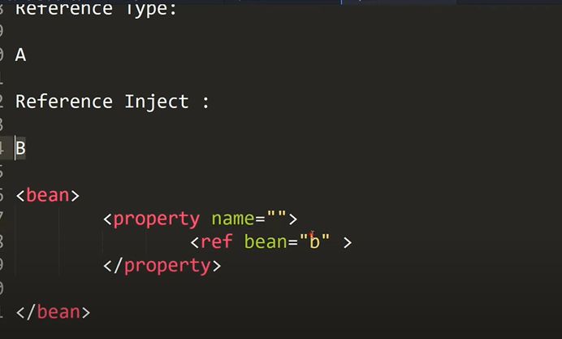
Config.xml
<?xml version="1.0" encoding="UTF-8"?>
<beans xmlns="http://www.springframework.org/schema/beans"
xmlns:xsi="http://www.w3.org/2001/XMLSchema-instance"
xmlns:context="http://www.springframework.org/schema/context"
xmlns:p="http://www.springframework.org/schema/p"
xsi:schemaLocation="http://www.springframework.org/schema/beans
http://www.springframework.org/schema/beans/spring-beans.xsd
http://www.springframework.org/schema/context
http://www.springframework.org/schema/context/spring-context.xsd">

<bean class="com.springcore.ref.B" name="bref">
<property name="y" value="90" />
</bean>

<bean class="com.springcore.ref.A" name="aref">
<property name="x" value="12" />
<property name="ob">
<ref bean="bref" />
</property>
</bean>

</beans>

A.java
package com.springcore.ref;

public class A {
private int x;
private B ob;

public A() {
super();
// TODO Auto-generated constructor stub
}

public A(int x, B ob) {
super();
this.x = x;
this.ob = ob;
}

@Override
public String toString() {
return "A [x=" + x + ", ob=" + ob + "]";
}

public int getX() {
return x;
}

public void setX(int x) {
this.x = x;
}

public B getOb() {
return ob;
}

public void setOb(B ob) {
this.ob = ob;
}

public static void main(String[] args) {
// TODO Auto-generated method stub

}

}

B.java
package com.springcore.ref;

public class B {
private int y;

@Override
public String toString() {
return "B [y=" + y + "]";
}

public B() {
super();
// TODO Auto-generated constructor stub
}

public B(int y) {
super();
this.y = y;
}

public int getY() {
return y;
}

public void setY(int y) {
this.y = y;
}

}

Test.java
package com.springcore.ref;

import org.springframework.context.ApplicationContext;
import org.springframework.context.support.ClassPathXmlApplicationContext;

public class T {

public static void main(String[] args) {
ApplicationContext context=new ClassPathXmlApplicationContext("com/springcore/ref/cnf.xml");
A temp = (A) context.getBean("aref");
System.out.println(temp.getX());
System.out.println(temp.getOb().getY());
System.out.println(temp);

}

}

Constructor Injection Complete Explanation

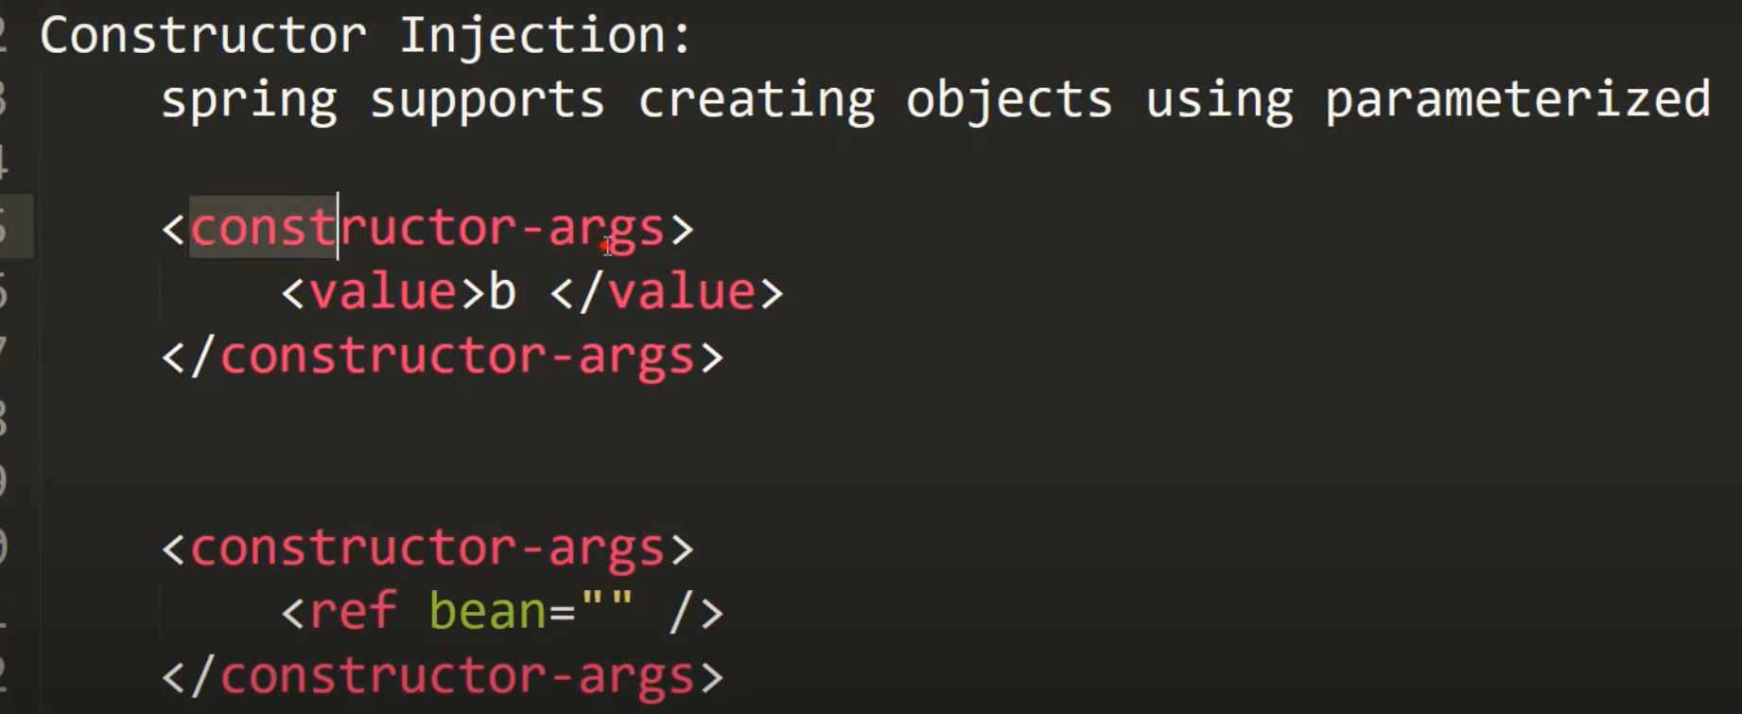
Simple Example
Conf.xml
<?xml version="1.0" encoding="UTF-8"?>
<beans xmlns="http://www.springframework.org/schema/beans"
xmlns:xsi="http://www.w3.org/2001/XMLSchema-instance"
xmlns:context="http://www.springframework.org/schema/context"
xmlns:p="http://www.springframework.org/schema/p"
xsi:schemaLocation="http://www.springframework.org/schema/beans
http://www.springframework.org/schema/beans/spring-beans.xsd
http://www.springframework.org/schema/context
http://www.springframework.org/schema/context/spring-context.xsd">

<bean class="com.springcore.CI.Person" name="Person">
<constructor-arg value="Yash"></constructor-arg>
<constructor-arg value="23" type="int"></constructor-arg>
</bean>
<bean class="com.springcore.CI.Person" name="Person1">
<constructor-arg value="Tanmay"></constructor-arg>
<constructor-arg value="24" type="int"></constructor-arg>
</bean>

</beans>

Person.java
package com.springcore.CI;

public class Person {
private String Name;
private int Age;
public Person(String Name, int Age) {
super();
this.Name = Name;
this.Age = Age;
}
@Override
public String toString() {
return "Person [Name=" + this.Name + ", Age=" + this.Age + "]";
}

}

TestCI.java
package com.springcore.CI;

import org.springframework.context.ApplicationContext;
import org.springframework.context.support.ClassPathXmlApplicationContext;

public class Test {

public static void main(String[] args) {
ApplicationContext context=new ClassPathXmlApplicationContext("com/springcore/CI/conf.xml");
Person p1= (Person) context.getBean("Person");
System.out.println(p1);

Person p2= (Person) context.getBean("Person1");
System.out.println(p2);

}

}

For Injecting Reference Using Constructor
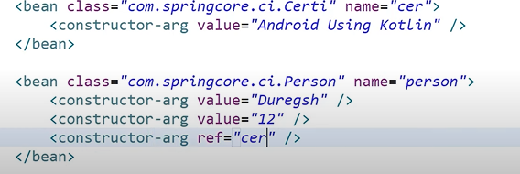
<?xml version="1.0" encoding="UTF-8"?>
<beans xmlns="http://www.springframework.org/schema/beans"
xmlns:xsi="http://www.w3.org/2001/XMLSchema-instance"
xmlns:context="http://www.springframework.org/schema/context"
xmlns:p="http://www.springframework.org/schema/p"
xsi:schemaLocation="http://www.springframework.org/schema/beans
http://www.springframework.org/schema/beans/spring-beans.xsd
http://www.springframework.org/schema/context
http://www.springframework.org/schema/context/spring-context.xsd">
<bean class="com.springcore.CI.Certificate" name="cer1">
<constructor-arg value="Cad_cam Automation Course"></constructor-arg>
</bean>

<bean class="com.springcore.CI.Certificate" name="cer2">
<constructor-arg value="Java Full Stack Course"></constructor-arg>
</bean>

<bean class="com.springcore.CI.Person" name="Person">
<constructor-arg value="Yash"></constructor-arg>
<constructor-arg value="23" type="int"></constructor-arg>
<constructor-arg ref="cer2"></constructor-arg>
</bean>
<bean class="com.springcore.CI.Person" name="Person1">
<constructor-arg value="Tanmay"></constructor-arg>
<constructor-arg value="24" type="int"></constructor-arg>
<constructor-arg ref="cer1"></constructor-arg>
</bean>

</beans>

For Collection same as previous (List)
<bean name="..." class="...">
<constructor-arg value="12"/>
<constructor-arg value="XYZ"/>
<constructor-arg ref="person1"/>
<constructor-arg>
<list>
<value>ABC</value>
<value>XYZ</value>
<value>PQR</value>
</list>
</constructor-arg>
<?xml version="1.0" encoding="UTF-8"?>
<beans xmlns="http://www.springframework.org/schema/beans"
xmlns:xsi="http://www.w3.org/2001/XMLSchema-instance"
xmlns:context="http://www.springframework.org/schema/context"
xmlns:p="http://www.springframework.org/schema/p"
xsi:schemaLocation="http://www.springframework.org/schema/beans
http://www.springframework.org/schema/beans/spring-beans.xsd
http://www.springframework.org/schema/context
http://www.springframework.org/schema/context/spring-context.xsd">
<bean class="com.springcore.CI.Certificate" name="cer1">
<constructor-arg value="Cad_cam Automation Course"></constructor-arg>
</bean>

<bean class="com.springcore.CI.Certificate" name="cer2">
<constructor-arg value="Java Full Stack Course"></constructor-arg>
</bean>

<bean class="com.springcore.CI.Person" name="Person">
<constructor-arg value="Yash"></constructor-arg>
<constructor-arg value="23" type="int"></constructor-arg>
<constructor-arg ref="cer2"></constructor-arg>
<constructor-arg>
<list>
<value>Virat Kohli</value>
<value>Kl Rahul</value>
</list>
</constructor-arg>
</bean>
<bean class="com.springcore.CI.Person" name="Person1">
<constructor-arg value="Tanmay"></constructor-arg>
<constructor-arg value="24" type="int"></constructor-arg>
<constructor-arg ref="cer1"></constructor-arg>
<constructor-arg>
<list>
<value>Rohit Sharma</value>
<value>Jasprit Bumrah</value>

</list>
</constructor-arg>
</bean>

</beans>

Ambiguity Problem and its Solution with Constructor Injection

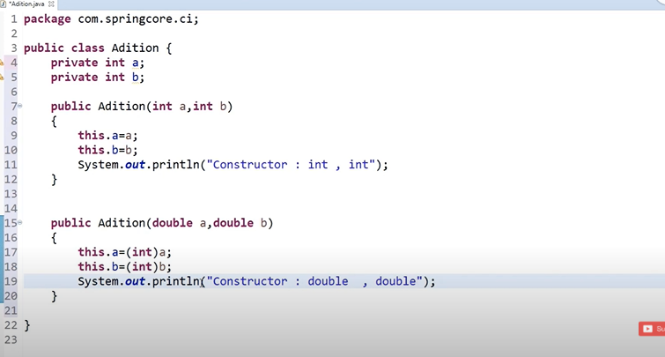
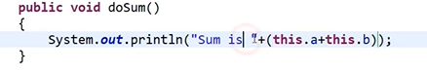
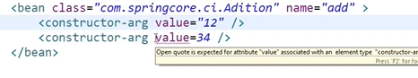
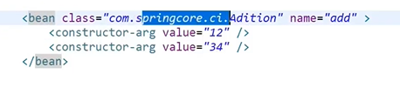

In case of Constructor Overloading the constructor at top will have 1st preference and will be called first if after value we don’t mention types.
Except – it takes string as default
Its called Ambuiguity
Indexing also we can do
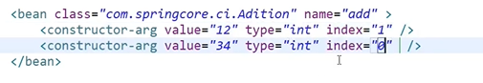

Life Cycle methods of Spring Bean
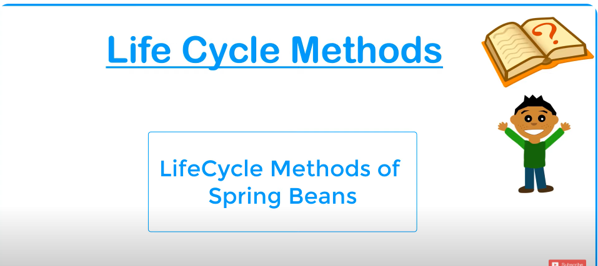

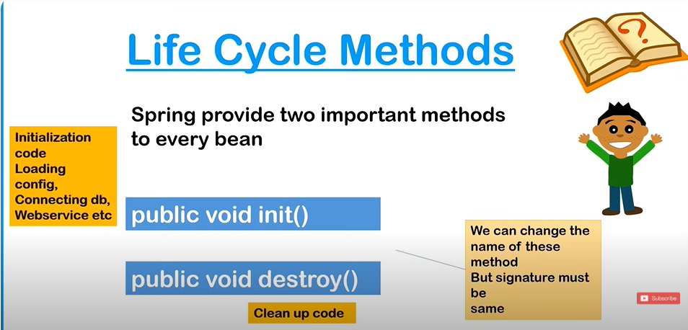
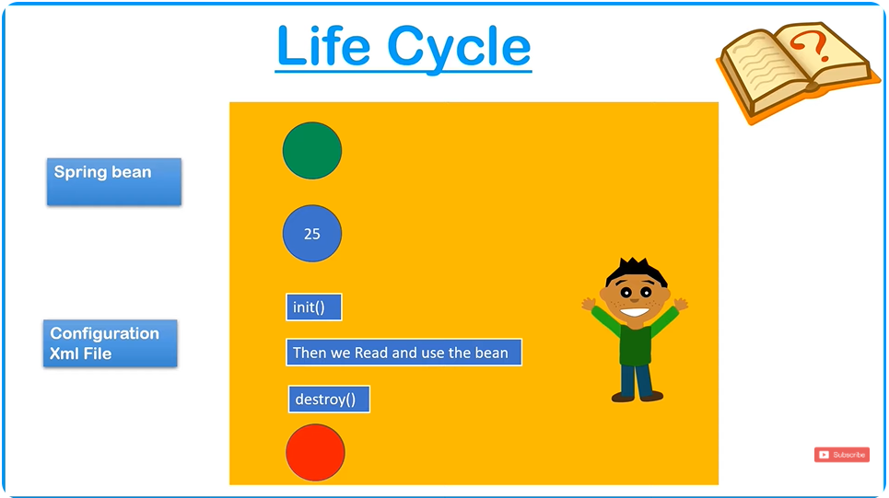
In Spring Framework, the lifecycle of a bean refers to the process of managing the bean from creation to destruction by the Spring container. Spring provides several ways to customize the lifecycle of beans, such as initializing beans, applying lifecycle callbacks, and performing cleanup.

Life Cycle of Spring Beans
Spring beans go through several stages during their lifecycle. Below are the important methods involved in the lifecycle of a Spring bean:

1. Bean Instantiation
- What happens: When a bean is defined in the Spring container (either in XML, Java config, or annotations), it is instantiated by the container. Spring creates an instance of the class.
- When: This happens as soon as the Spring container starts up and the bean is required.

2. Populate Bean Properties (Dependency Injection)
- What happens: After the bean is instantiated, Spring’s dependency injection mechanism is applied. Spring populates the properties of the bean with values, either via constructor injection, setter injection, or field injection.
- When: This step happens after the bean is instantiated and before any lifecycle callback methods are called.

3. Set Bean Name (BeanNameAware interface)
- What happens: If the bean implements the BeanNameAware interface, Spring will call its setBeanName() method. This method allows the bean to know the name that Spring has assigned to it.
  - Method signature: void setBeanName(String name)
  - Use case: If the bean needs to know its name as it is defined in the container, this is the point where Spring provides that information.

4. Set Bean’s BeanFactory (BeanFactoryAware interface)
- What happens: If the bean implements the BeanFactoryAware interface, Spring will call its setBeanFactory() method. This method gives the bean a reference to the BeanFactory that created it.
  - Method signature: void setBeanFactory(BeanFactory beanFactory)
  - Use case: Allows the bean to interact with the BeanFactory, such as retrieving other beans or interacting with the Spring container.

5. Set ApplicationContext (ApplicationContextAware interface)
- What happens: If the bean implements the ApplicationContextAware interface, Spring calls its setApplicationContext() method. This method allows the bean to get a reference to the Spring ApplicationContext.
  - Method signature: void setApplicationContext(ApplicationContext context)
  - Use case: If the bean needs to interact with the context or other beans in the container, it can access it through this method.

6. Pre-Initialization (BeanPostProcessor interface)
- What happens: Before the bean’s initialization method is called, Spring gives a chance for any custom logic to be executed via BeanPostProcessor implementations.
  - Method signature: Object postProcessBeforeInitialization(Object bean, String beanName)
  - Use case: If you need to apply custom logic or modifications before the bean’s initialization (like setting properties or wrapping the bean in a proxy), this method is invoked.

7. Custom Initialization Method
- What happens: If the bean is configured with an initialization method (either through XML, Java configuration, or annotations), this method is called after the bean's properties have been set.
  - Method signature: void afterPropertiesSet() (for InitializingBean interface) or a custom method (specified using init-method in XML or @PostConstruct annotation).
  - Use case: Perform any additional initialization tasks after the bean’s properties have been set, such as opening resources or preparing external connections.
    - @PostConstruct Annotation: If using annotations, @PostConstruct will be called once the bean properties have been set.
    - InitializingBean Interface: If the bean implements InitializingBean, the afterPropertiesSet() method will be called.

8. Post-Initialization (BeanPostProcessor interface)
- What happens: After the bean’s initialization method is called, Spring gives a chance for further customization via the BeanPostProcessor interface.
  - Method signature: Object postProcessAfterInitialization(Object bean, String beanName)
  - Use case: This is typically used for any post-initialization logic or to decorate the bean (e.g., wrapping the bean in a proxy).

9. Bean Ready for Use
- What happens: At this point, the bean is fully initialized and ready to be used by the Spring container. It will be available for dependency injection into other beans.

10. Destruction of Bean (Optional)
- What happens: When the Spring container is shut down, Spring will invoke the destroy methods to clean up the bean.
- When: This happens when the context is closed or the application is being terminated.
  - Method Signature: void destroy() (for DisposableBean interface) or a custom method (configured with destroy-method in XML or @PreDestroy annotation).
  - @PreDestroy Annotation: If using annotations, @PreDestroy is invoked before the bean is destroyed.
  - DisposableBean Interface: If the bean implements DisposableBean, the destroy() method will be called.

Full Bean Lifecycle (Example)
Here is a simple example showing some of the lifecycle methods:
java
Copy code
import javax.annotation.PostConstruct;
import javax.annotation.PreDestroy;
import org.springframework.beans.factory.BeanNameAware;
import org.springframework.beans.factory.InitializingBean;
import org.springframework.beans.factory.DisposableBean;

public class ExampleBean implements BeanNameAware, InitializingBean, DisposableBean {

private String name;

@PostConstruct
public void postConstruct() {
System.out.println("PostConstruct: Bean initialized");
}

public void setBeanName(String name) {
System.out.println("Bean name is " + name);
}

public void afterPropertiesSet() {
System.out.println("InitializingBean: Bean properties set");
}

public void destroy() {
System.out.println("DisposableBean: Bean destroyed");
}

@PreDestroy
public void preDestroy() {
System.out.println("PreDestroy: Cleaning up before destruction");
}

public void setName(String name) {
this.name = name;
}

public String getName() {
return name;
}
}

Explanation of Lifecycle Steps in the Example:
- Instantiation: The ExampleBean is instantiated by Spring.
- Dependency Injection: Spring injects properties (if any).
- Set Bean Name: The setBeanName() method is called if the bean implements BeanNameAware.
- @PostConstruct: The postConstruct() method is invoked.
- Initialization (afterPropertiesSet() or custom method): afterPropertiesSet() is called, or any custom initialization method (like init-method) is called.
- Bean Ready for Use: The bean is now available for use by the Spring container.
- Destruction (destroy() or @PreDestroy): When the context is closed, destroy() or @PreDestroy is called to clean up resources.

Summary of Lifecycle Methods:
- Instantiation (Spring creates the bean).
- Dependency Injection (Bean properties are injected).
- setBeanName() (if BeanNameAware).
- setBeanFactory() (if BeanFactoryAware).
- setApplicationContext() (if ApplicationContextAware).
- Pre-initialization (via BeanPostProcessor).
- Initialization (afterPropertiesSet(), @PostConstruct, or custom method).
- Post-initialization (via BeanPostProcessor).
- Bean ready for use.
- Destruction (destroy(), @PreDestroy, or DisposableBean).

These lifecycle methods help you customize your beans' behavior at various stages and ensure that resources are cleaned up properly.
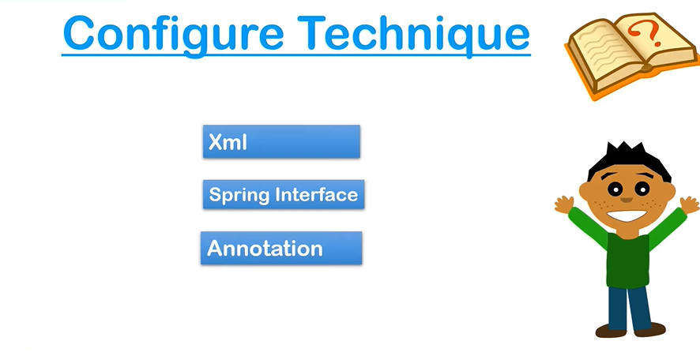
Done for D day

Implementing Lifecycle methods Using XML
Conf.xml
<?xml version="1.0" encoding="UTF-8"?>
<beans xmlns="http://www.springframework.org/schema/beans"
xmlns:xsi="http://www.w3.org/2001/XMLSchema-instance"
xmlns:context="http://www.springframework.org/schema/context"
xmlns:p="http://www.springframework.org/schema/p"
xsi:schemaLocation="http://www.springframework.org/schema/beans
http://www.springframework.org/schema/beans/spring-beans.xsd
http://www.springframework.org/schema/context
http://www.springframework.org/schema/context/spring-context.xsd">

<bean class="com.springcore.lifecycle.King" name="k1" init-method="init" destroy-method="destroy">
<property name="name" value="Virat Kohli"></property>
</bean>

</beans>
King.java
package com.springcore.lifecycle;

public class King {
private String name;

public String getName() {
return name;
}

public void setName(String name) {
System.out.println(".............Setting VAlues...........");
this.name = name;
}

public King(String name) {
super();
this.name = name;
}

public King() {
super();
// TODO Auto-generated constructor stub
}

@Override
public String toString() {
return "King [name=" + name + "]";
}
public void init()
{
System.out.println(".............Inside Init Method..............");

}
public void destroy()
{
System.out.println(".............Inside Destroy Method..............");
}
}

Test.java
package com.springcore.lifecycle;
import org.springframework.context.support.AbstractApplicationContext;
import org.springframework.context.ApplicationContext;
import org.springframework.context.support.ClassPathXmlApplicationContext;

import com.springcore.CI.Person;

public class Test {

public static void main(String[] args) {
AbstractApplicationContext context=new ClassPathXmlApplicationContext("com/springcore/lifecycle/conf.xml");
King k1= (King) context.getBean("k1");
System.out.println(k1);
context.registerShutdownHook();
}

}

Implementing bean life cycle using interfaces | IntializingBean | DisposableBean

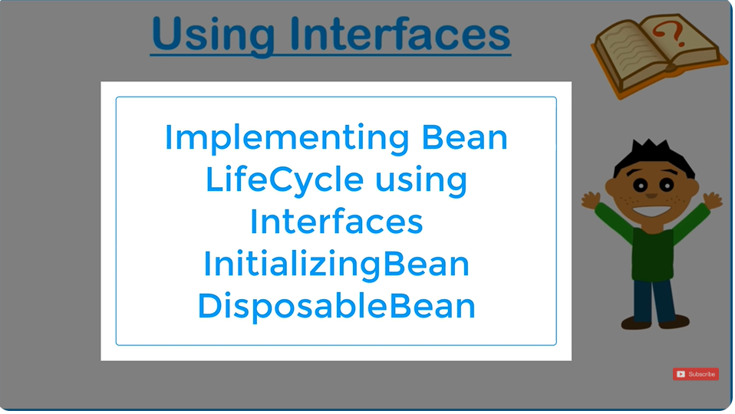

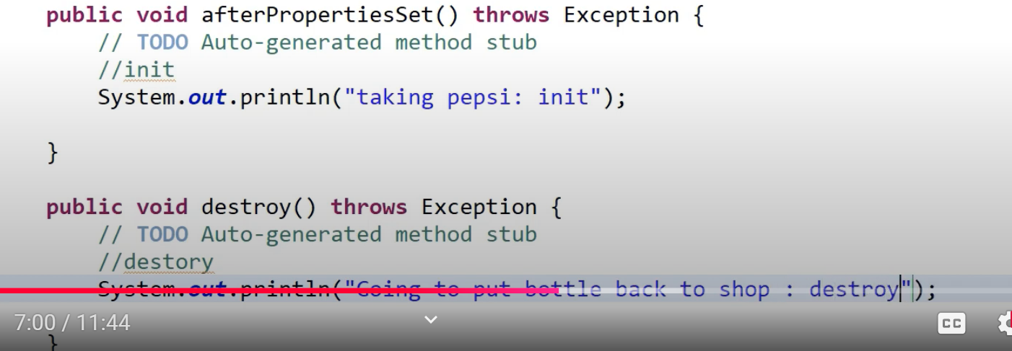

Implementing Bean LifeCyle using Annotations | @PostConstruct | @PreDestroy
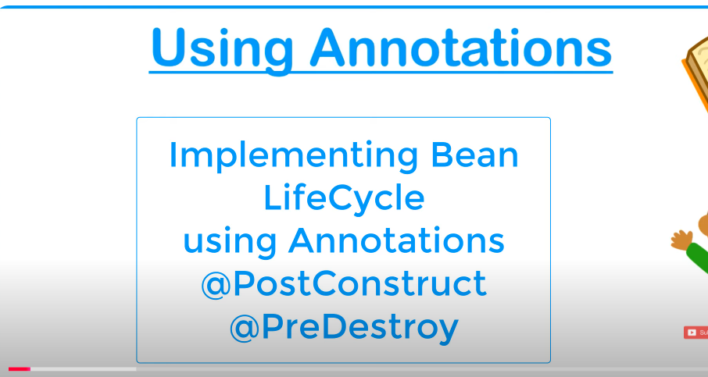

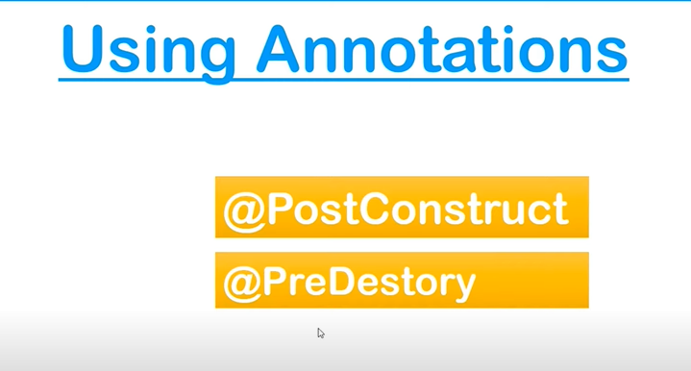
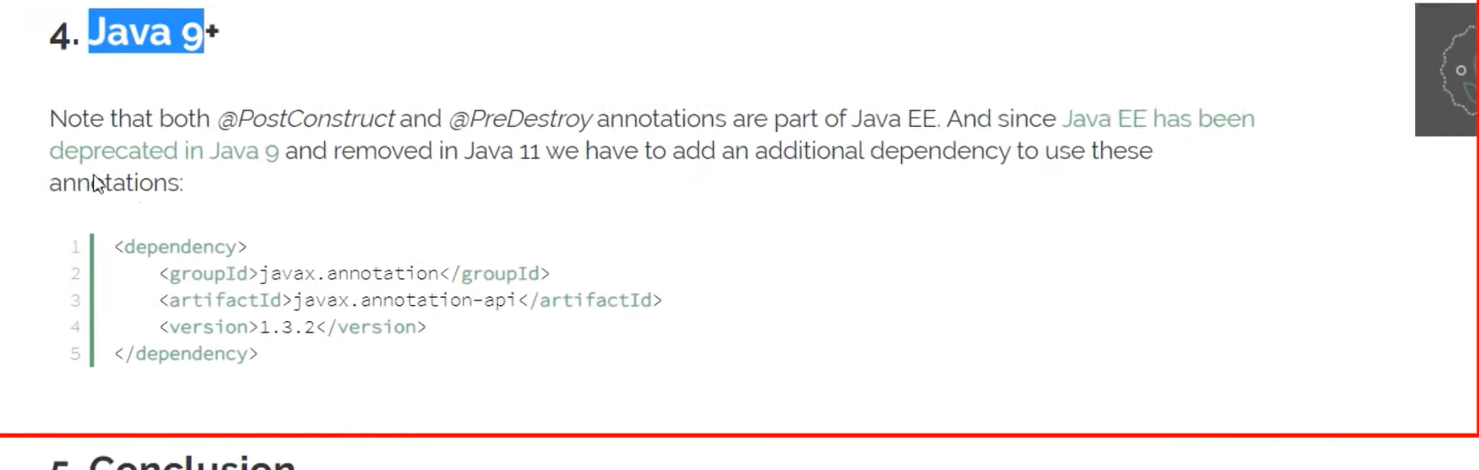
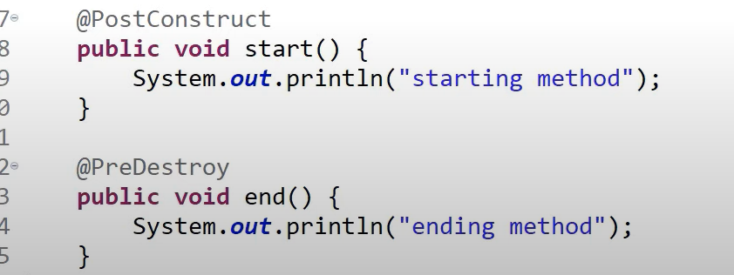
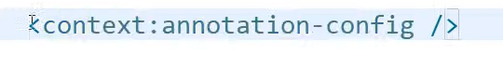
Autowiring in Spring Framework


Autowiring in Spring Framework is a feature that allows Spring to automatically inject dependencies into a bean by matching its properties with beans defined in the configuration file or context. This helps reduce boilerplate code for explicit dependency injection.
How Autowiring Works
Autowiring works by matching bean properties in a class with available beans in the Spring container. Spring uses reflection to determine the appropriate bean to inject based on the wiring mode specified.

Autowiring Modes
- No Autowiring (autowire="no")
  - Default mode.
  - Explicit bean configuration is required (e.g., via property tags in XML or manual setters).
  - No autowiring is performed.
xml
Copy code
<bean id="student" class="com.example.Student">
<property name="address" ref="addressBean" />
</bean>

- By Type (autowire="byType")
  - Spring injects a bean by matching the type of the property in the class.
  - If multiple beans of the same type are present, Spring throws an exception unless a primary bean is specified.
xml
Copy code
<bean id="student" class="com.example.Student" autowire="byType" />
  - Example:
java
Copy code
public class Student {
private Address address; // Automatically wired if a bean of type Address exists

// Getter and setter
}

- By Name (autowire="byName")
  - Spring injects a bean by matching the property name with the bean's id.
  - The property name in the class must match the bean's name in the Spring configuration.
xml
Copy code
<bean id="address" class="com.example.Address" />
<bean id="student" class="com.example.Student" autowire="byName" />
  - Example:
java
Copy code
public class Student {
private Address address; // Will match with the bean named "address"

// Getter and setter
}

- Constructor (autowire="constructor")
  - Spring injects dependencies by matching beans with the constructor arguments.
  - If multiple constructor arguments exist, Spring resolves them by matching types.
xml
Copy code
<bean id="address" class="com.example.Address" />
<bean id="student" class="com.example.Student" autowire="constructor" />
  - Example:
java
Copy code
public class Student {
private Address address;

public Student(Address address) {
this.address = address; // Dependency injected through constructor
}
}

- Autodetect (autowire="autodetect") (Deprecated)
  - Spring first tries constructor-based autowiring.
  - If no constructor is found, it falls back to byType autowiring.
  - Mostly replaced by annotations in modern Spring.

Using Annotations for Autowiring (Preferred Approach)
Spring provides annotations to simplify autowiring:
- @Autowired
  - Automatically wires a bean by type.
  - Can be applied to fields, constructors, or setters.
  - Requires @Component or @Bean for beans to be managed by the container.
  - Example:
java
Copy code
@Component
public class Student {
@Autowired
private Address address; // Dependency will be injected by type
}
- @Qualifier
  - Used with @Autowired to resolve conflicts when multiple beans of the same type exist.
  - Example:
java
Copy code
@Component
public class Student {
@Autowired
@Qualifier("primaryAddress")
private Address address; // Specifically injects the "primaryAddress" bean
}
- @Primary
  - Marks a bean as the default choice for autowiring when multiple beans of the same type exist.
  - Example:
java
Copy code
@Primary
@Component("defaultAddress")
public class Address {
// Primary bean
}

Key Points to Remember
- Autowiring reduces manual configuration and is ideal for injecting dependencies dynamically.
- Use annotations like @Autowired, @Qualifier, and @Primary in modern Spring applications instead of XML-based configurations.
- Always ensure that beans are uniquely identifiable to avoid NoUniqueBeanDefinitionException.
- If autowiring fails to find a matching bean, Spring throws a NoSuchBeanDefinitionException.

Example with Annotations
java
Copy code
@Component
public class Address {
private String city = "New York";

public String getCity() {
return city;
}
}

@Component
public class Student {
@Autowired
private Address address;

public void displayInfo() {
System.out.println("City: " + address.getCity());
}
}

// Main Application
@SpringBootApplication
public class App {
public static void main(String[] args) {
ApplicationContext context = SpringApplication.run(App.class, args);
Student student = context.getBean(Student.class);
student.displayInfo(); // Output: City: New York
}
}

This demonstrates how autowiring simplifies dependency injection while maintaining flexibility.
4o

Note- Will be used only for objects

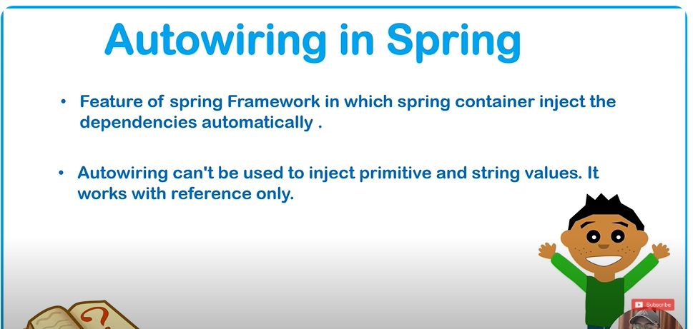
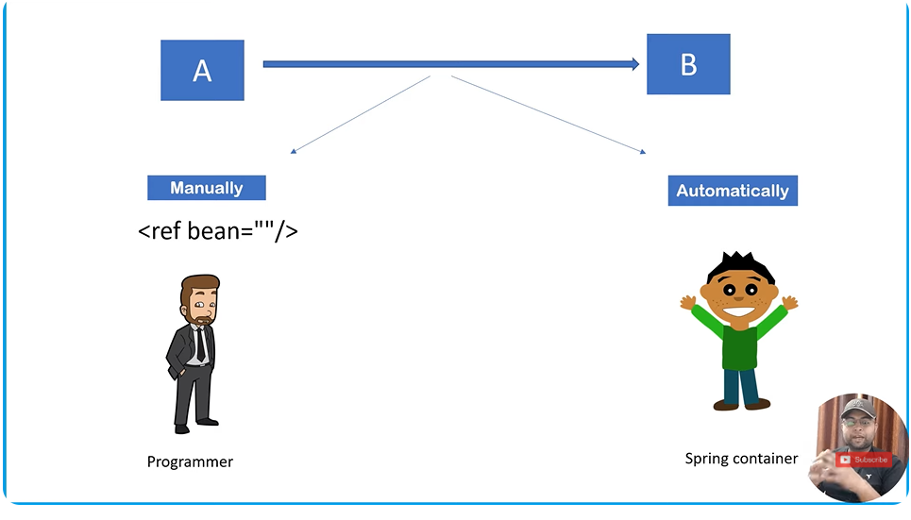
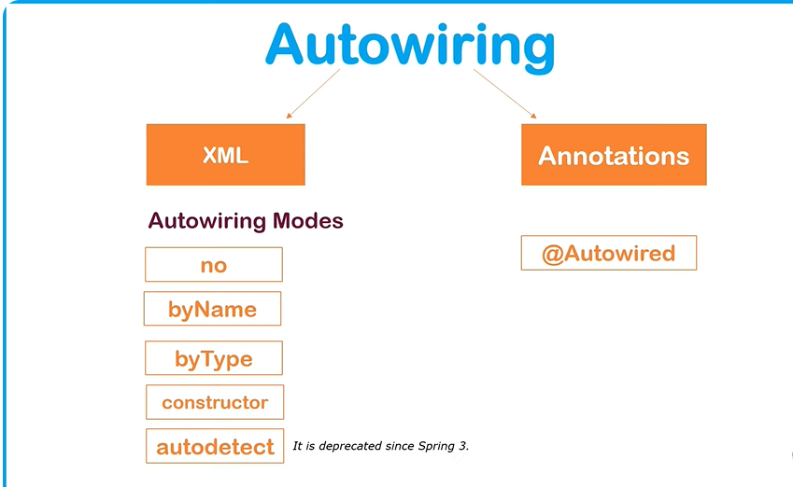
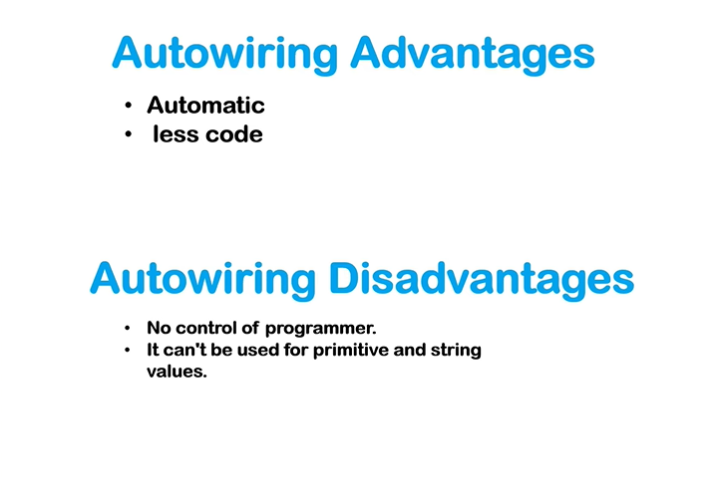
Autowiring using XML complete Session | byName | byType | byConstructor | Spring Tutorial



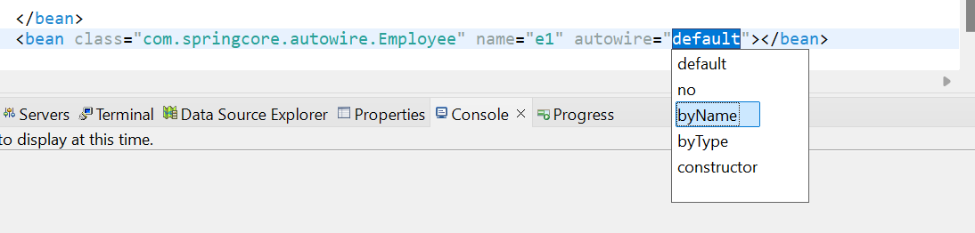
Byname will check the name of reference in config.xml
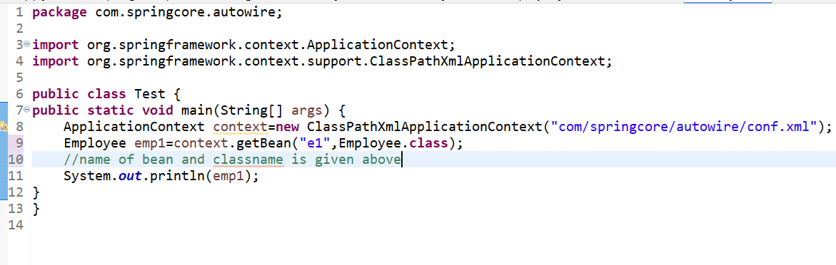
In bytype it will check type of bean i.e Address in our example
But if we have two objects of same type ref which is always the case
ByType will then throw exception
In ByName also same Exception will occur
No Autowire might be good

@Autowired Annotation for Autowiring | Autowiring in Spring Framework | Spring Framework Tutorial
The @Autowired annotation in Spring is used for automatic dependency injection. It allows Spring to resolve and inject collaborating beans into your class without explicitly wiring them in configuration files.

How @Autowired Works
- Spring scans for the @Autowired annotation during the application context initialization.
- It looks for a matching bean in the context:
  - By type (e.g., if a UserService type is required, it looks for a bean of that type).
  - If more than one bean of the same type exists, it uses the name of the field or setter method (unless specified by @Qualifier).
  - If no suitable bean is found, it throws a NoSuchBeanDefinitionException.

Usage

1. On a Field
java
Copy code
@Component
public class UserController {
@Autowired
private UserService userService;

public void performAction() {
userService.processUser();
}
}
- Pros: Simplest and shortest syntax.
- Cons: Field injection is not recommended for unit testing since it makes the class harder to mock.

2. On a Constructor
java
Copy code
@Component
public class UserController {
private final UserService userService;

@Autowired
public UserController(UserService userService) {
this.userService = userService;
}

public void performAction() {
userService.processUser();
}
}
- Pros: Constructor injection is preferred for immutability and better testability.
- Cons: Slightly more verbose.

3. On a Setter Method
java
Copy code
@Component
public class UserController {
private UserService userService;

@Autowired
public void setUserService(UserService userService) {
this.userService = userService;
}

public void performAction() {
userService.processUser();
}
}
- Pros: Allows optional dependencies.
- Cons: Verbose compared to field or constructor injection.

Using @Qualifier
When multiple beans of the same type exist, use @Qualifier to specify which bean to inject:
java
Copy code
@Autowired
@Qualifier("specificUserService")
private UserService userService;
Define beans with names in configuration:
java
Copy code
@Bean(name = "specificUserService")
public UserService userService() {
return new SpecificUserService();
}

Key Points
- The class where @Autowired is used must be managed by Spring (annotated with @Component, @Service, etc.).
- The default behavior is required=true. To make a dependency optional:
java
Copy code
@Autowired(required = false)
private Optional<UserService> userService;
- Use @Primary to mark one bean as the default when multiple candidates exist:
java
Copy code
@Primary
@Bean
public UserService defaultUserService() {
return new DefaultUserService();
}

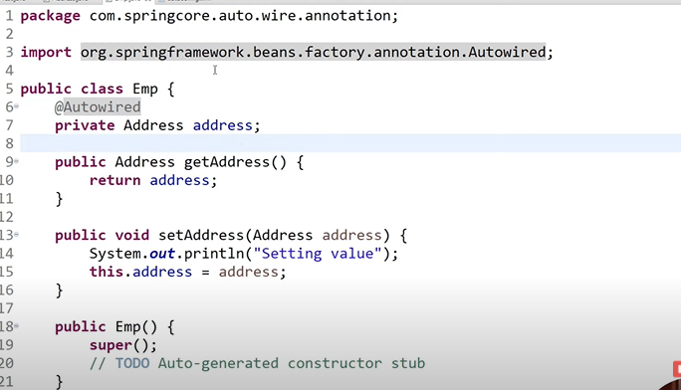
We have to use @Autowired Annotation above property to be wired
In xml just enable by
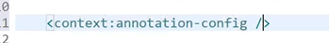
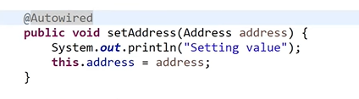
@Qualifier Annotation with Autowiring | Spring Framework Tutorial

The @Qualifier annotation in Spring is used along with @Autowired to resolve ambiguity when there are multiple beans of the same type in the Spring context. It helps specify exactly which bean should be injected into a dependent component.

Why Use @Qualifier?
When multiple beans of the same type exist in the Spring container, @Autowired alone cannot determine which one to inject. In such cases, Spring throws a NoUniqueBeanDefinitionException. The @Qualifier annotation allows you to explicitly specify which bean to use.

How @Qualifier Works
- The @Qualifier annotation is placed next to @Autowired to specify the name of the bean to inject.
- The bean name provided in @Qualifier must match the id or name of a bean defined in the Spring configuration.

Example: Using @Qualifier with @Autowired

1. Defining Beans
java
Copy code
@Component("primaryAddress")
public class Address {
private String city = "New York";

public String getCity() {
return city;
}
}

@Component("secondaryAddress")
public class Address {
private String city = "Los Angeles";

public String getCity() {
return city;
}
}

2. Injecting with @Qualifier
java
Copy code
@Component
public class Student {
@Autowired
@Qualifier("primaryAddress")
private Address address; // Injects the "primaryAddress" bean

public void displayInfo() {
System.out.println("City: " + address.getCity());
}
}

3. Main Application
java
Copy code
@SpringBootApplication
public class App {
public static void main(String[] args) {
ApplicationContext context = SpringApplication.run(App.class, args);
Student student = context.getBean(Student.class);
student.displayInfo(); // Output: City: New York
}
}

How to Use in XML Configuration
If you're using XML-based configuration, you can achieve a similar effect with the qualifier attribute in the <property> tag.

XML Example
xml
Copy code
<bean id="primaryAddress" class="com.example.Address">
<property name="city" value="New York" />
</bean>

<bean id="secondaryAddress" class="com.example.Address">
<property name="city" value="Los Angeles" />
</bean>

<bean id="student" class="com.example.Student">
<property name="address" ref="primaryAddress" />
</bean>

Additional Use Cases
- With Constructor Injection
java
Copy code
@Component
public class Student {
private Address address;

@Autowired
public Student(@Qualifier("primaryAddress") Address address) {
this.address = address;
}
}
- With Setter Injection
java
Copy code
@Component
public class Student {
private Address address;

@Autowired
@Qualifier("secondaryAddress")
public void setAddress(Address address) {
this.address = address;
}
}

Key Points to Remember
- Use Case: @Qualifier is necessary only when multiple beans of the same type exist.
- Bean Name: The name in @Qualifier should match the bean's id (XML) or component name (@Component("beanName")).
- Avoiding Ambiguity: Use @Primary to specify a default bean, and combine it with @Qualifier for finer control.
- Modern Approach: While XML configuration works, annotations like @Qualifier are preferred in modern Spring applications for clarity and maintainability.

Real-World Scenario
- Use Case: You have multiple implementations of an interface (e.g., PaymentService) for handling different payment gateways like PayPal and Stripe.
java
Copy code
@Component("paypalService")
public class PayPalService implements PaymentService {
public void pay() {
System.out.println("Payment processed via PayPal");
}
}

@Component("stripeService")
public class StripeService implements PaymentService {
public void pay() {
System.out.println("Payment processed via Stripe");
}
}

@Component
public class PaymentProcessor {
@Autowired
@Qualifier("paypalService")
private PaymentService paymentService; // Injects PayPalService

public void processPayment() {
paymentService.pay();
}
}

// Main Application
@SpringBootApplication
public class App {
public static void main(String[] args) {
ApplicationContext context = SpringApplication.run(App.class, args);
PaymentProcessor processor = context.getBean(PaymentProcessor.class);
processor.processPayment(); // Output: Payment processed via PayPal
}
}
This flexibility allows fine-grained control over bean injection, making @Qualifier a critical tool in Spring development.
4o

Spring Standalone Collections[List,Map,Properties] | Util Schema in Spring | Spring Tutorial

Spring Standalone Collections
Spring Framework provides support for injecting collections like List, Set, Map, and Properties into beans. These are referred to as Standalone Collections because they are not tied to any specific business logic but are useful for passing configuration data or other values to beans.

1. Supported Collection Types in Spring
- List: Ordered collection that allows duplicates.
- Set: Unordered collection that doesn't allow duplicates.
- Map: Collection of key-value pairs.
- Properties: Subclass of Map for storing key-value pairs, specifically designed for configuration properties.

2. Injecting Collections in Spring

Using XML Configuration
- Injecting a List
xml
Copy code
<bean id="student" class="com.example.Student">
<property name="subjects">
<list>
<value>Math</value>
<value>Science</value>
<value>English</value>
</list>
</property>
</bean>
- Injecting a Set
xml
Copy code
<bean id="student" class="com.example.Student">
<property name="skills">
<set>
<value>Java</value>
<value>Python</value>
<value>Spring</value>
</set>
</property>
</bean>
- Injecting a Map
xml
Copy code
<bean id="student" class="com.example.Student">
<property name="grades">
<map>
<entry key="Math" value="A" />
<entry key="Science" value="B" />
<entry key="English" value="A+" />
</map>
</property>
</bean>
- Injecting Properties
xml
Copy code
<bean id="student" class="com.example.Student">
<property name="config">
<props>
<prop key="database.url">jdbc:mysql://localhost:3306/school</prop>
<prop key="database.user">root</prop>
<prop key="database.password">password</prop>
</props>
</property>
</bean>

Using Annotations
You can also inject collections using the @Value and @Autowired annotations. However, this is less common compared to XML for collections.

3. Example Class
A Student class with collection properties:
java
Copy code
package com.example;

import java.util.List;
import java.util.Map;
import java.util.Properties;
import java.util.Set;

public class Student {
private List<String> subjects;
private Set<String> skills;
private Map<String, String> grades;
private Properties config;

// Getters and setters
public void setSubjects(List<String> subjects) {
this.subjects = subjects;
}

public void setSkills(Set<String> skills) {
this.skills = skills;
}

public void setGrades(Map<String, String> grades) {
this.grades = grades;
}

public void setConfig(Properties config) {
this.config = config;
}

@Override
public String toString() {
return "Student [subjects=" + subjects +
", skills=" + skills +
", grades=" + grades +
", config=" + config + "]";
}
}

4. Util Schema in Spring
The util namespace in Spring simplifies working with collections in XML configuration. Instead of verbose XML, you can use <util:list>, <util:set>, <util:map>, and <util:properties> tags.

Enable util Schema
To use the util schema, include the following in your XML file:
xml
Copy code
xmlns:util="http://www.springframework.org/schema/util"
http://www.springframework.org/schema/util http://www.springframework.org/schema/util/spring-util.xsd

Util Schema Examples
- Using <util:list>
xml
Copy code
<util:list id="subjectList">
<value>Math</value>
<value>Science</value>
<value>English</value>
</util:list>
- Using <util:set>
xml
Copy code
<util:set id="skillSet">
<value>Java</value>
<value>Python</value>
</util:set>
- Using <util:map>
xml
Copy code
<util:map id="gradeMap">
<entry key="Math" value="A" />
<entry key="Science" value="B" />
</util:map>
- Using <util:properties>
xml
Copy code
<util:properties id="dbConfig">
<prop key="database.url">jdbc:mysql://localhost:3306/school</prop>
<prop key="database.user">root</prop>
<prop key="database.password">password</prop>
</util:properties>

5. Injecting Util Collections into Beans
You can inject collections created with the util namespace into beans:
xml
Copy code
<bean id="student" class="com.example.Student">
<property name="subjects" ref="subjectList" />
<property name="skills" ref="skillSet" />
<property name="grades" ref="gradeMap" />
<property name="config" ref="dbConfig" />
</bean>

6. Advantages of Util Schema
- Simplified XML: Reduces verbosity in defining collections.
- Reusability: You can define collections once and reuse them across multiple beans.
- Readability: Makes XML easier to read and maintain.

By using standalone collections and the util schema effectively, you can configure your beans with complex data structures in a clean and maintainable way.
To check implementation class

UTIL SCHEMA IN DETAILS

Util Schema in Spring Framework
The util schema in Spring simplifies working with collections such as List, Set, Map, and Properties in XML configuration. It provides concise and reusable ways to define and inject collections into Spring beans.

Enable util Schema in XML
To use the util schema, include the following namespace declaration and schema definition in your XML file:
xml
Copy code
<beans xmlns="http://www.springframework.org/schema/beans"
xmlns:util="http://www.springframework.org/schema/util"
xmlns:xsi="http://www.w3.org/2001/XMLSchema-instance"
xsi:schemaLocation="
http://www.springframework.org/schema/beans
http://www.springframework.org/schema/beans/spring-beans.xsd
http://www.springframework.org/schema/util
http://www.springframework.org/schema/util/spring-util.xsd">

Util Schema Tags

1. <util:list>
Defines a List of values.
xml
Copy code
<util:list id="subjectList">
<value>Math</value>
<value>Science</value>
<value>English</value>
</util:list>

2. <util:set>
Defines a Set of unique values.
xml
Copy code
<util:set id="skillSet">
<value>Java</value>
<value>Python</value>
<value>Spring</value>
</util:set>

3. <util:map>
Defines a Map with key-value pairs.
xml
Copy code
<util:map id="gradeMap">
<entry key="Math" value="A" />
<entry key="Science" value="B+" />
<entry key="English" value="A+" />
</util:map>

4. <util:properties>
Defines a Properties object for configuration.
xml
Copy code
<util:properties id="dbConfig">
<prop key="database.url">jdbc:mysql://localhost:3306/school</prop>
<prop key="database.user">root</prop>
<prop key="database.password">password</prop>
</util:properties>

Injecting Util Schema Collections into Beans
Once defined, the collections can be injected into beans using the ref attribute.

Example Bean Configuration:
xml
Copy code
<bean id="student" class="com.example.Student">
<property name="subjects" ref="subjectList" />
<property name="skills" ref="skillSet" />
<property name="grades" ref="gradeMap" />
<property name="config" ref="dbConfig" />
</bean>

Corresponding Student Class:
java
Copy code
package com.example;

import java.util.List;
import java.util.Map;
import java.util.Properties;
import java.util.Set;

public class Student {
private List<String> subjects;
private Set<String> skills;
private Map<String, String> grades;
private Properties config;

public void setSubjects(List<String> subjects) {
this.subjects = subjects;
}

public void setSkills(Set<String> skills) {
this.skills = skills;
}

public void setGrades(Map<String, String> grades) {
this.grades = grades;
}

public void setConfig(Properties config) {
this.config = config;
}

@Override
public String toString() {
return "Student [subjects=" + subjects +
", skills=" + skills +
", grades=" + grades +
", config=" + config + "]";
}
}

Advantages of Util Schema
- Cleaner XML: Reduces verbosity for defining and injecting collections.
- Reusability: Collections defined with util tags can be reused across multiple beans.
- Maintainability: Makes it easier to manage collections in a centralized way
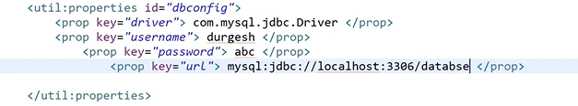

Conf.java for the same
<?xml version="1.0" encoding="UTF-8"?>
<beans xmlns="http://www.springframework.org/schema/beans"
xmlns:xsi="http://www.w3.org/2001/XMLSchema-instance"
xmlns:context="http://www.springframework.org/schema/context"
xmlns:p="http://www.springframework.org/schema/p"
xmlns:util="http://www.springframework.org/schema/util"
xsi:schemaLocation="http://www.springframework.org/schema/beans
http://www.springframework.org/schema/beans/spring-beans.xsd
http://www.springframework.org/schema/context
http://www.springframework.org/schema/context/spring-context.xsd
http://www.springframework.org/schema/util
http://www.springframework.org/schema/util/spring-util.xsd">

<!-- Example of a standalone List -->
<util:list list-class="java.util.LinkedList" id="myfavplayers">
<value>Virat King Kohli</value>
<value>Rohit Sharma</value>
<value>Jasprit Bumrah</value>
<value>KL Rahul</value>
</util:list>
<!--Example of StandAlone MAP-->
<util:map map-class="java.util.HashMap" id="mycourse">
<entry key="Java Full Stack Developer" value="6 Months"></entry>
<entry key="Python Full Stack Developer" value="4 Months"></entry>

<entry key=" Web Developer" value="4 Months"></entry>

</util:map>

<!--Example of StandAlone Property-->
<util:properties id="dbconfig">
<prop key="driver">com.mysql.jdbc.Driver</prop>
<prop key="username">Light</prop>
<prop key="password">Light</prop>
<prop key="url">mysql:jdbc://localhost:3306/Testdatabase</prop>
</util:properties>

<!-- Bean Configuration -->
<bean class="com.springcore.standalone.collections.Person" name="p1">
<property name="favplayer">
<ref bean="myfavplayers"/>

</property>
<property name="course">
<ref bean="mycourse" />

</property>
<property name="property">
<ref bean="dbconfig" />
</property>
</bean>
<!--Another method-->
<bean class="com.springcore.standalone.collections.Person" name="p2">
<property name="favplayer" ref="myfavplayers"></property>
<property name="course" ref="mycourse"></property>
<property name="property" ref="dbconfig"></property>
</bean>

</beans>

Person.java
package com.springcore.standalone.collections;

import java.util.List;
import java.util.Map;
import java.util.Properties;

public class Person {
private List<String> favplayer;
private Map<String, String> course;
private Properties property;

public Person(List<String> favplayer, Map<String, String> course, Properties property) {
super();
this.favplayer = favplayer;
this.course = course;
this.property = property;
}

public Properties getProperty() {
return property;
}

public void setProperty(Properties property) {
this.property = property;
}

public Person(List<String> favplayer, Map<String, String> course) {
super();
this.favplayer = favplayer;
this.course = course;
}

public Map<String, String> getCourse() {
return course;
}

public void setCourse(Map<String, String> course) {
this.course = course;
}

public List<String> getFavplayer() {
return favplayer;
}

public void setFavplayer(List<String> favplayer) {
this.favplayer = favplayer;
}

public Person(List<String> favplayer) {
super();
this.favplayer = favplayer;
}

public Person() {
super();
// TODO Auto-generated constructor stub
}

@Override
public String toString() {
return "Person [favplayer=" + favplayer + ", course=" + course + ", property=" + property + "]";
}

}

Test.java
package com.springcore.standalone.collections;

import org.springframework.context.ApplicationContext;
import org.springframework.context.support.ClassPathXmlApplicationContext;

public class Test {

public static void main(String[] args) {
ApplicationContext context=new ClassPathXmlApplicationContext("com/springcore/standalone/collections/conf.xml");
Person per1=(Person) context.getBean("p1");
System.out.println(per1.getFavplayer());
System.out.println(per1.getCourse());
System.out.println(per1.getProperty());

System.out.println("______________________________________________________________________________");

Person per2=(Person) context.getBean("p2");
System.out.println(per2.getFavplayer());
System.out.println(per2.getCourse());
System.out.println(per2.getProperty());
System.out.println("______________________________________________________________________________");

System.out.println(per1.getFavplayer().getClass().getName());
System.out.println(per1.getCourse().getClass().getName());
System.out.println(per1.getProperty().getClass().getName());

}

}

Stereotype Annotations | @Component Annotation | @Value Annotation | Spring Tutorial

Stereotype Annotations
Stereotype annotations in Spring are used to define Spring-managed beans. These annotations simplify application development by marking a class with a specific role in the application. All stereotype annotations are automatically registered as beans in the Spring container, provided component scanning is enabled.

Key Stereotype Annotations:
- @Component:
  - Generic annotation for a Spring bean.
  - Suitable for any type of component in the application.
  - Example: Utility classes or simple business logic components.
- @Repository:
  - Specialized annotation for persistence layer components (DAOs).
  - Automatically translates persistence-related exceptions into Spring's DataAccessException.
- @Service:
  - Specialized annotation for service layer components.
  - Represents the business logic in the application.
- @Controller:
  - Specialized annotation for Spring MVC controllers.
  - Used to define handler methods for HTTP requests.

@Component Annotation
The @Component annotation marks a class as a Spring bean, making it eligible for detection during component scanning. It's a generic stereotype for Spring-managed components.

Key Points:
- Automatically detected by Spring if component scanning is enabled.
- Can be used for utility classes or general-purpose beans.

How to Use @Component:
- Create a Component:
java
Copy code
@Component
public class MyService {
public void performTask() {
System.out.println("Task performed!");
}
}
- Enable Component Scanning:
  - Use Java configuration:
java
Copy code
@Configuration
@ComponentScan(basePackages = "com.example")
public class AppConfig { }
  - Alternatively, use XML configuration:
xml
Copy code
<context:component-scan base-package="com.example"/>
- Access the Component:
java
Copy code
public static void main(String[] args) {
ApplicationContext context = new AnnotationConfigApplicationContext(AppConfig.class);
MyService service = context.getBean(MyService.class);
service.performTask();
}

@Value Annotation
The @Value annotation is used to inject values into fields, constructor arguments, or method parameters. These values can come from:
- Literal values (hardcoded strings or numbers).
- Property files (like application.properties).
- Environment variables.
- SpEL (Spring Expression Language) expressions.

Key Points:
- Provides flexibility to configure application properties dynamically.
- Often used with external configuration files.

How to Use @Value:
- Injecting Hardcoded Values:
java
Copy code
@Component
public class MyComponent {
@Value("Hello, Spring!")
private String message;

public void displayMessage() {
System.out.println(message);
}
}
- Injecting Values from a Property File: Property File (application.properties):
properties
Copy code
app.name=MySpringApp
app.version=1.0.0
Spring Component:
java
Copy code
@Component
public class AppInfo {
@Value("${app.name}")
private String appName;

@Value("${app.version}")
private String appVersion;

public void displayInfo() {
System.out.println("App Name: " + appName);
System.out.println("App Version: " + appVersion);
}
}
- Default Values:
java
Copy code
@Value("${non.existent.property:DefaultValue}")
private String defaultValue;
- Injecting Collections: Property File:
properties
Copy code
app.items=item1,item2,item3
Spring Component:
java
Copy code
@Component
public class CollectionDemo {
@Value("#{'${app.items}'.split(',')}")
private List<String> items;

public void displayItems() {
items.forEach(System.out::println);
}
}

Summary
- Stereotype Annotations:
  - Define roles of beans in the Spring application.
  - Common types: @Component, @Service, @Repository, @Controller.
- @Component:
  - Generic annotation to mark a class as a Spring bean.
  - Requires component scanning to register the bean.
- @Value:
  - Injects values into Spring components.
  - Supports literals, property files, environment variables, and SpEL.

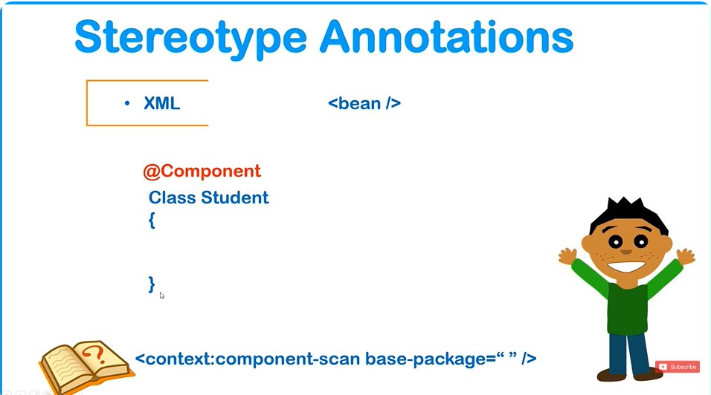
We can use Stereotype Annotations instead of Beans in XML Notations
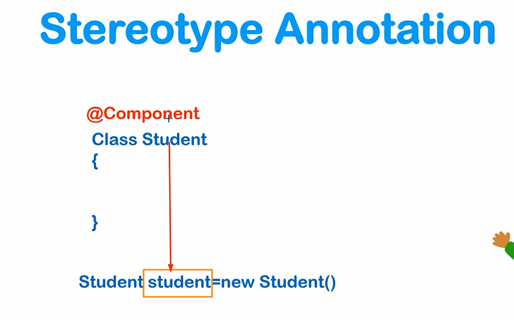
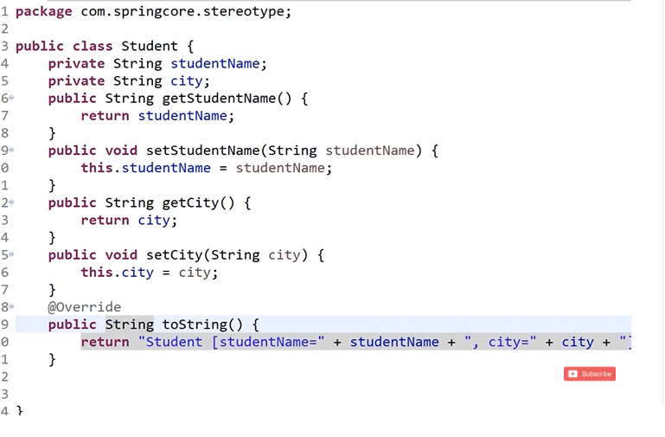
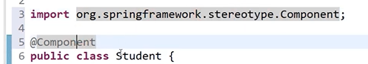
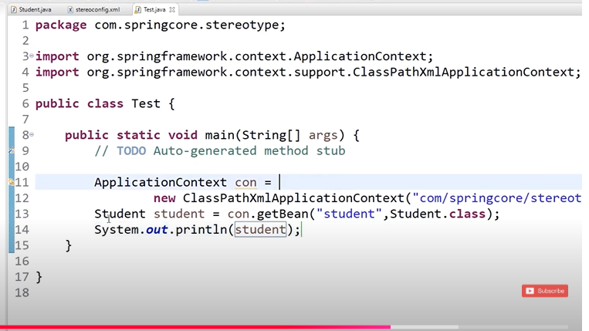
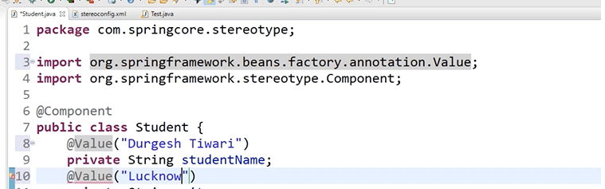
Put values using @Value annotations
Now putting collections using this
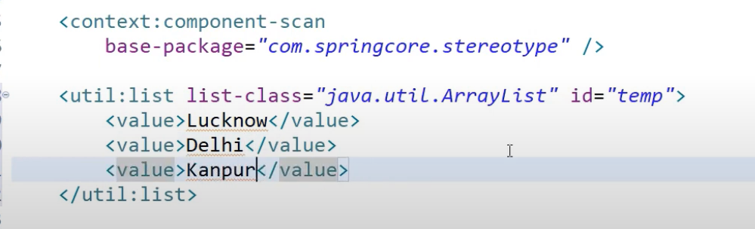
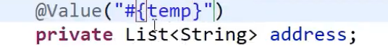

Spring Bean Scope | Singleton | Prototype | how to configure scope
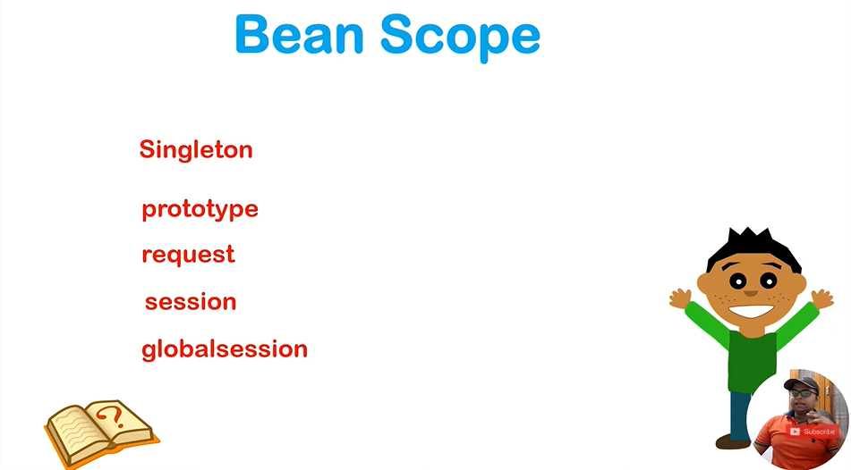

Spring Bean Scope
In Spring, the scope of a bean defines its lifecycle and how it is created, used, and destroyed within the Spring container. The framework provides multiple scopes for managing beans depending on the application's requirements.

Types of Bean Scopes
- Singleton (Default Scope):
  - Only one instance of the bean is created per Spring container.
  - The same instance is shared across the entire application.
Use Case: Stateless, shared components like configuration or utility classes.
- Prototype:
  - A new instance of the bean is created every time it is requested.
  - The container does not manage the complete lifecycle (e.g., destroy methods are not called).
Use Case: Stateful or lightweight beans where each request needs a unique instance.
- Request (Web applications only):
  - A single instance of the bean is created for each HTTP request.
  - Available only during the lifecycle of a single HTTP request.
Use Case: Request-specific data handling.
- Session (Web applications only):
  - A single instance of the bean is created per HTTP session.
  - The bean remains active as long as the session is active.
Use Case: Session-specific data handling.
- Global Session (Web applications using portlets):
  - A single instance of the bean is created per global HTTP session.
Use Case: Scoped for global session portlets.
- Application (Web applications only):
  - A single instance of the bean is created per ServletContext.
Use Case: Application-wide shared objects.

How to Configure Scope
You can configure the scope of a Spring bean using:
- XML Configuration
- Annotation Configuration

1. XML Configuration
In the XML configuration, the scope can be set using the scope attribute in the <bean> definition.
Example:
xml
Copy code
<bean id="singletonBean" class="com.example.MyClass" scope="singleton"/>
<bean id="prototypeBean" class="com.example.MyClass" scope="prototype"/>

2. Annotation Configuration
In Spring, you can use the @Scope annotation to specify the bean scope along with the @Component or @Bean annotation.
Example:
java
Copy code
import org.springframework.context.annotation.Scope;
import org.springframework.stereotype.Component;

@Component
@Scope("singleton") // Default Scope
public class SingletonBean {
// Bean logic here
}

@Component
@Scope("prototype")
public class PrototypeBean {
// Bean logic here
}

Scopes in @Bean Methods
If you're using Java configuration with @Bean:
java
Copy code
@Configuration
public class AppConfig {

@Bean
@Scope("singleton")
public SingletonBean singletonBean() {
return new SingletonBean();
}

@Bean
@Scope("prototype")
public PrototypeBean prototypeBean() {
return new PrototypeBean();
}
}

Testing Singleton vs Prototype
To understand the difference between Singleton and Prototype scopes, consider this example:
Singleton Scope:
java
Copy code
ApplicationContext context = new AnnotationConfigApplicationContext(AppConfig.class);
SingletonBean bean1 = context.getBean(SingletonBean.class);
SingletonBean bean2 = context.getBean(SingletonBean.class);

System.out.println(bean1 == bean2); // true (same instance)
Prototype Scope:
java
Copy code
ApplicationContext context = new AnnotationConfigApplicationContext(AppConfig.class);
PrototypeBean bean1 = context.getBean(PrototypeBean.class);
PrototypeBean bean2 = context.getBean(PrototypeBean.class);

System.out.println(bean1 == bean2); // false (different instances)

Available Scopes
You can use the following scope values in both XML and annotation configurations:
- singleton (default)
- prototype
- request (web-only)
- session (web-only)
- application (web-only)
- global-session (portlets)

Summary
- Singleton:
  - Single instance per container.
  - Default scope.
- Prototype:
  - New instance per request.
  - Useful for stateful beans.
- Configuration:
  - Use scope attribute in XML or @Scope annotation in Java.
- Web Scopes:
  - Scopes like request, session, application, and global-session are specific to web applications.
Hashcode gives us object code
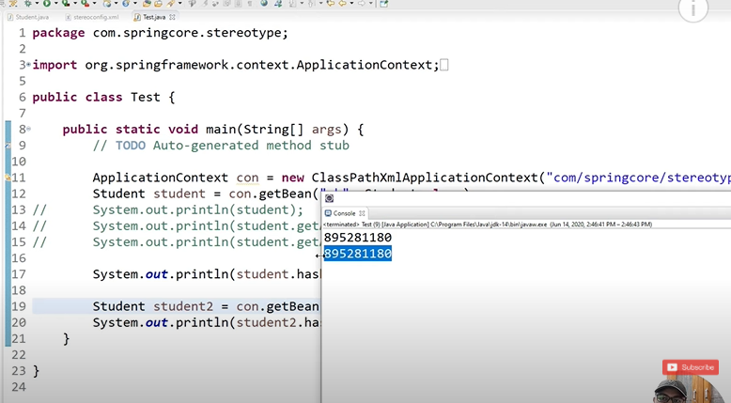
Both times IOC container gave same object(This Singleton scope)(This isByDefault Scope)
Now letsgo do prototype
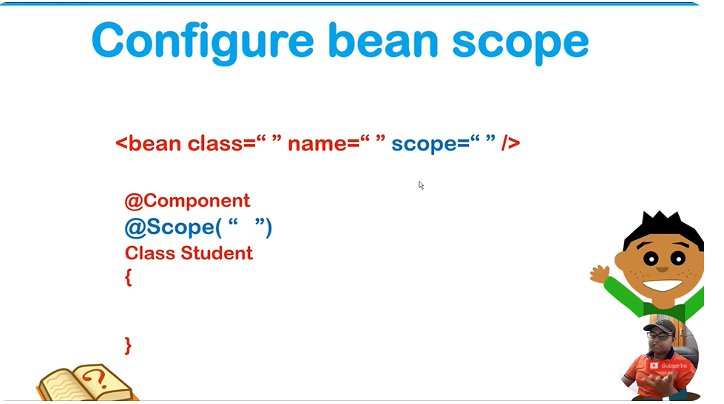
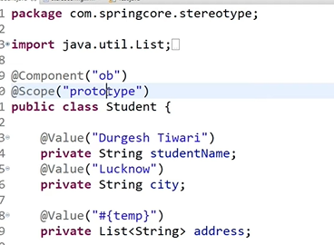
Using XML Method

Spring Expression Language | SpEL | what is SpEL | How to use Expression

Spring Expression Language (SpEL)
Spring Expression Language (SpEL) is a powerful expression language integrated into the Spring Framework. It enables querying and manipulating objects at runtime in a concise and dynamic way. It can be used within configuration files, annotations, or programmatically in Java code.

What is SpEL?
SpEL is similar to other expression languages, like OGNL or EL, but is specifically designed for Spring. It provides support for:
- Accessing properties.
- Calling methods.
- Evaluating arithmetic and logical expressions.
- Working with arrays, collections, and maps.
- Templating.
- Accessing environment properties or bean definitions.

Key Features of SpEL
- Property Access:
  - Accessing properties of objects.
  - Example: person.name
- Method Invocation:
  - Call methods on objects.
  - Example: person.getName()
- Arithmetic Operators:
  - Supports +, -, *, /, %, etc.
  - Example: 10 + 20
- Logical Operators:
  - Supports and, or, not.
  - Example: isAvailable and isDiscounted
- Collections:
  - Access elements in arrays, lists, maps, etc.
  - Example: array[0], list[1], map['key']
- Relational Operators:
  - Supports ==, !=, <, <=, >, >=.
  - Example: age > 18
- Regex Matching:
  - Matches strings against a regular expression.
  - Example: 'Spring'.matches('[A-Za-z]+')
- Variables:
  - Access or define variables using the # symbol.
  - Example: #myVar

How to Use SpEL
SpEL can be used in 3 ways:
- In XML Configuration.
- With Annotations.
- Programmatically in Java.

1. SpEL in XML Configuration
SpEL expressions can be embedded in XML-based Spring configurations using the #{} syntax.
Example:
xml
Copy code
<bean id="person" class="com.example.Person">
<property name="name" value="John"/>
<property name="age" value="30"/>
</bean>

<bean id="ageAfter10Years" class="java.lang.Integer">
<constructor-arg value="#{person.age + 10}"/>
</bean>
In this example, the value of ageAfter10Years will be set to 40 (person's age + 10).

2. SpEL with Annotations
SpEL can also be used directly within annotations, like @Value, to inject values dynamically.
Example:
java
Copy code
import org.springframework.beans.factory.annotation.Value;
import org.springframework.stereotype.Component;

@Component
public class Person {
@Value("John") // Static value
private String name;

@Value("#{30 + 5}") // SpEL expression for age
private int age;

@Value("#{systemProperties['user.name']}") // Accessing system properties
private String systemUser;

// Getters and setters
}

3. SpEL Programmatically
You can also evaluate SpEL expressions in your code using the ExpressionParser.
Example:
java
Copy code
import org.springframework.expression.ExpressionParser;
import org.springframework.expression.spel.standard.SpelExpressionParser;

public class SpELExample {
public static void main(String[] args) {
// Create SpEL parser
ExpressionParser parser = new SpelExpressionParser();

// Evaluate expressions
String name = parser.parseExpression("'Hello Spring!'").getValue(String.class);
int sum = parser.parseExpression("10 + 20").getValue(Integer.class);
boolean isAdult = parser.parseExpression("25 > 18").getValue(Boolean.class);

// Print results
System.out.println("Name: " + name); // Hello Spring!
System.out.println("Sum: " + sum); // 30
System.out.println("Is Adult: " + isAdult); // true
}
}

Common Use Cases of SpEL
- Injecting System Properties:
  - Example: @Value("#{systemProperties['os.name']}")
- Accessing Bean Properties:
  - Example: @Value("#{myBean.propertyName}")
- Conditional Logic:
  - Example: @Value("#{myBean.status == 'ACTIVE' ? 'Yes' : 'No'}")
- Collections and Maps:
  - Access or filter collections/maps dynamically.
  - Example: @Value("#{myMap['key']}")
- Arithmetic and Logical Operations:
  - Example: @Value("#{10 + 20}")

Summary
- What is SpEL?
  - A dynamic expression language for querying and manipulating objects at runtime.
- How to Use:
  - In XML (#{expression}).
  - With annotations (@Value).
  - Programmatically using ExpressionParser.
- Use Cases:
  - Evaluate expressions, inject dynamic values, access collections, filter, and perform logical/arithmetic operations.
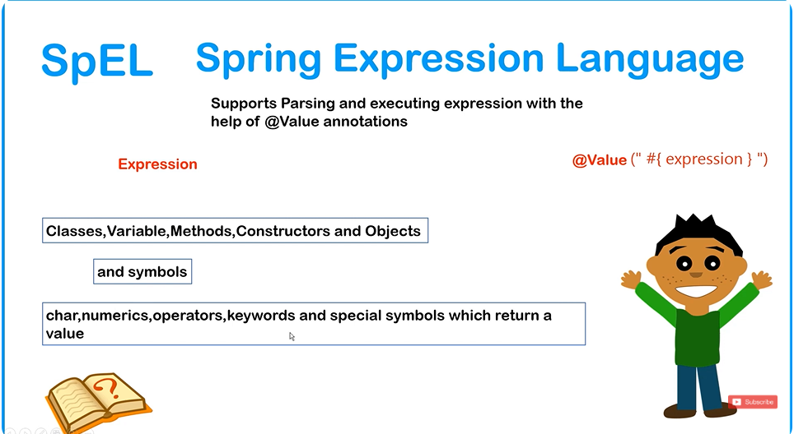
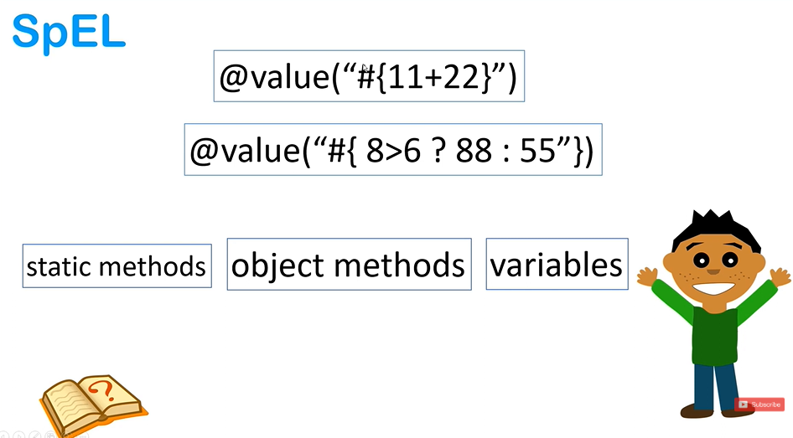

Test.java
package com.springcore.spel;

import org.springframework.context.ApplicationContext;
import org.springframework.context.support.ClassPathXmlApplicationContext;
import org.springframework.expression.Expression;
import org.springframework.expression.spel.standard.SpelExpressionParser;

public class Test {
public static void main(String[] args) {
ApplicationContext context=new ClassPathXmlApplicationContext("com/springcore/spel/config.xml");
Demo d1=context.getBean("demo",Demo.class);
System.out.println(d1);
System.out.println(d1.getX());
System.out.println(d1.getY());

SpelExpressionParser temp = new SpelExpressionParser();
Expression expression = temp.parseExpression("122 + 414");
System.out.println(expression.getValue());

}
}

Config.xml
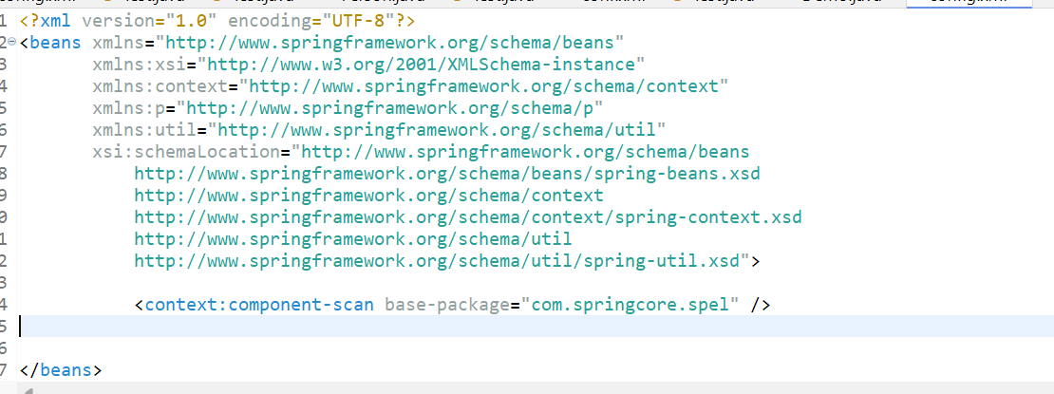
Only 1 line
Demo.java
package com.springcore.spel;

import org.springframework.beans.factory.annotation.Value;
import org.springframework.stereotype.Component;

@Component
public class Demo {

@Value("#{ 22 + 11 }")
private int x;
@Value("#{ 45 + 22 }")
private int y;
@Override
public String toString() {
return "Demo [x=" + x + ", y=" + y + "]";
}
public int getX() {
return x;
}
public void setX(int x) {
this.x = x;
}
public int getY() {
return y;
}
public void setY(int y) {
this.y = y;
}

}

How to invoke static method , variables and creating object | Spring Expression Language

In Spring Expression Language (SpEL), you can invoke static methods, access static variables, and create objects using expressions. Here's how you can do it:

1. Invoking Static Methods
Use the T(className).methodName(args) syntax to call static methods.
Example:
java
Copy code
SpelExpressionParser parser = new SpelExpressionParser();
Expression expression = parser.parseExpression("T(java.lang.Math).sqrt(16)");
System.out.println(expression.getValue()); // Output: 4.0

2. Accessing Static Variables
Use the T(className).variableName syntax to access static variables.
Example:
java
Copy code
Expression expression = parser.parseExpression("T(java.lang.Math).PI");
System.out.println(expression.getValue()); // Output: 3.141592653589793

3. Creating New Objects
Use the new keyword to create new objects in SpEL.
Example:
java
Copy code
Expression expression = parser.parseExpression("new java.lang.String('Hello, SpEL!')");
System.out.println(expression.getValue()); // Output: Hello, SpEL!

Example in Spring Configuration (@Value)
You can also use these expressions in Spring annotations like @Value.
Example:
java
Copy code
@Value("#{T(java.lang.Math).sqrt(25)}")
private double squareRoot;

@Value("#{new java.util.Date()}")
private Date currentDate;

Using Static Imports in XML
To invoke static methods or variables in XML, configure the context namespace for Spring Expression Language.
XML Configuration:
xml
Copy code
<beans xmlns="http://www.springframework.org/schema/beans"
xmlns:context="http://www.springframework.org/schema/context"
xmlns:xsi="http://www.w3.org/2001/XMLSchema-instance"
xsi:schemaLocation="http://www.springframework.org/schema/beans
http://www.springframework.org/schema/beans/spring-beans.xsd
http://www.springframework.org/schema/context
http://www.springframework.org/schema/context/spring-context.xsd">

<!-- Example: Using SpEL -->
<bean id="exampleBean" class="com.example.MyClass">
<property name="staticValue" value="#{T(java.lang.Math).PI}"/>
<property name="newObject" value="#{new java.lang.String('Spring')}"/>
</bean>
</beans>
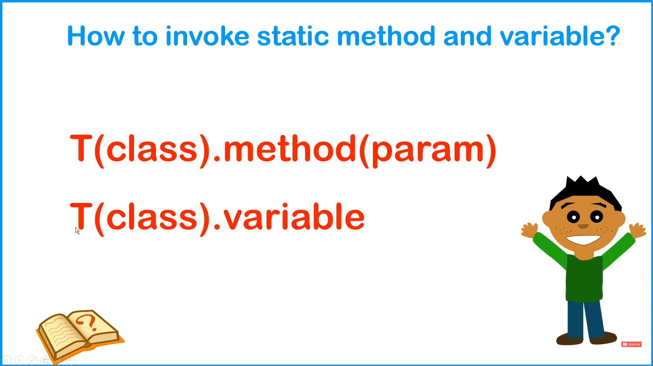
For booelans
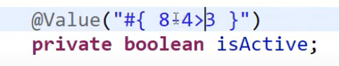

Removing Complete XML for Spring Configuration | @Configuration | @ComponentScan | @Bean Annotation

In Spring, you can remove XML configuration entirely by using Java-based configuration with annotations like @Configuration, @ComponentScan, and @Bean. Here's how to do it step by step:

1. Replace <beans> with @Configuration
The @Configuration annotation marks a class as a source of bean definitions.
java
Copy code
import org.springframework.context.annotation.Configuration;

@Configuration
public class AppConfig {
// Add bean definitions or other configurations here.
}

2. Replace <context:component-scan> with @ComponentScan
The @ComponentScan annotation scans for components in specified packages, replacing the <context:component-scan> tag.
java
Copy code
import org.springframework.context.annotation.ComponentScan;
import org.springframework.context.annotation.Configuration;

@Configuration
@ComponentScan(basePackages = "com.springcore")
public class AppConfig {
// Scans components, services, and repositories in the "com.springcore" package.
}

3. Define Beans with @Bean
The @Bean annotation is used to define beans directly in a @Configuration class, replacing the <bean> XML tag.
Example:
java
Copy code
import org.springframework.context.annotation.Bean;
import org.springframework.context.annotation.Configuration;

@Configuration
public class AppConfig {
@Bean
public MyService myService() {
return new MyService(); // Equivalent to <bean class="com.example.MyService"/>
}
}

4. Remove XML Example
XML Configuration (Old):
xml
Copy code
<beans xmlns="http://www.springframework.org/schema/beans"
xmlns:context="http://www.springframework.org/schema/context"
xmlns:xsi="http://www.w3.org/2001/XMLSchema-instance"
xsi:schemaLocation="http://www.springframework.org/schema/beans
http://www.springframework.org/schema/beans/spring-beans.xsd
http://www.springframework.org/schema/context
http://www.springframework.org/schema/context/spring-context.xsd">

<context:component-scan base-package="com.springcore"/>

<bean id="myService" class="com.springcore.MyService"/>
</beans>
Java Configuration (New):
java
Copy code
import org.springframework.context.annotation.Bean;
import org.springframework.context.annotation.ComponentScan;
import org.springframework.context.annotation.Configuration;

@Configuration
@ComponentScan(basePackages = "com.springcore")
public class AppConfig {
@Bean
public MyService myService() {
return new MyService();
}
}

5. Bootstrapping the Application
Instead of using ClassPathXmlApplicationContext, use AnnotationConfigApplicationContext.
Example:
java
Copy code
import org.springframework.context.ApplicationContext;
import org.springframework.context.annotation.AnnotationConfigApplicationContext;

public class MainApp {
public static void main(String[] args) {
ApplicationContext context = new AnnotationConfigApplicationContext(AppConfig.class);

MyService myService = context.getBean(MyService.class);
myService.performTask();
}
}

Advantages of Removing XML Configuration:
- Type Safety: IDE support for refactoring and type checks.
- Cleaner Code: Avoids verbose XML syntax.
- Easier Testing: You can directly create instances of configuration classes.
- Flexibility: More programmatic control over bean creation and lifecycle.
Using Component Scan
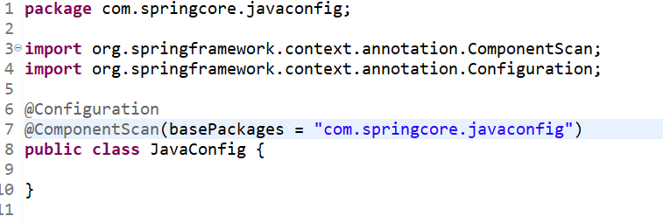
Test.Java


Student.java
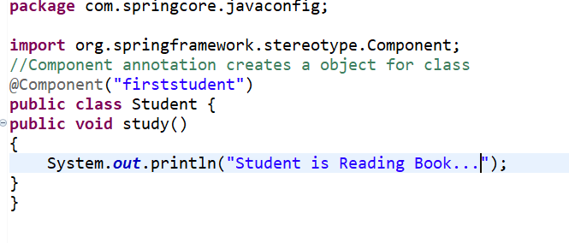
Now we will bring everything under Congifjava Class
Using @Bean Annotations
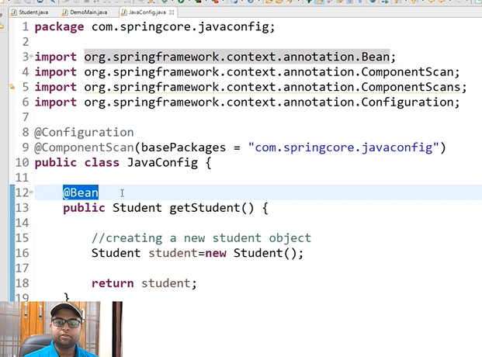
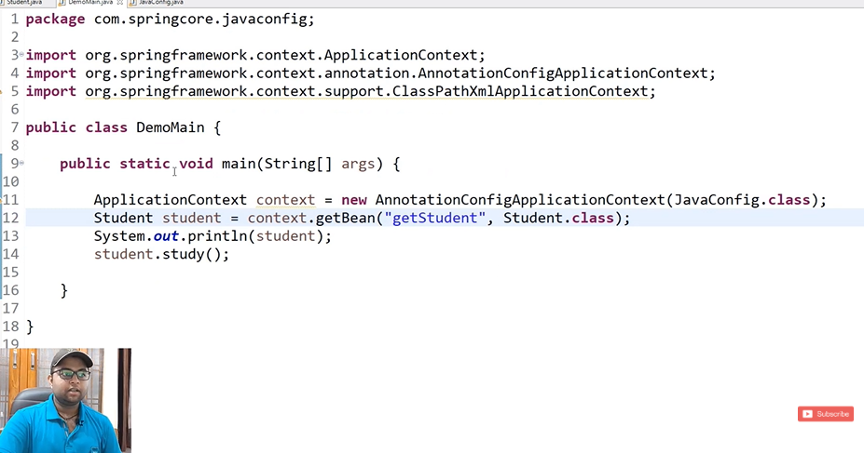
Method Name will be The same you give for reference
